Press Release for CREADIS3 project
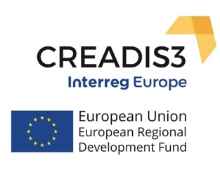
The interest shown by participants ensured the success of the 5th Stakeholder Group Meeting of the CREADIS3 – Interreg Europe project (Smart Specialisation Creative Districts) held at the “Lithografeion” Theater on Wednesday 24 October 2018, organized by the Regional Development Fund of the Region of Western Greece as one of its 6 partners from EU countries.
In this 5th meeting, the floor was given to the Theatre & Cinema Creative Ecosystem of the RWG, among an open and constructive atmosphere. Representatives from theatrical spaces – stages, local artists, the Ephorate of Antiquities of Achaia, the Municipality of Patras, the international festivals of Patras, of the Municipality of Ilida, and of Olympia (film festival for children and young people), the academic community, members of social cooperative enterprises and start-ups, as well as executives from the RWG and the RDF/RWG, were present.
Within the framework of the CREADIS3 project implementation and of the future short-term elaboration of a targeted Action Plan, a discussion was held with - both directly and indirectly - involved stakeholders from local public authorities, as well as research, entrepreneurship and civil society organizations. A consultation platform that was created specifically for this purpose was presented, and stakeholders active in the Culture & Creativity sectors were invited to take part in the dialogue, which will serve as a tool for the elaboration of a viable Action Plan. The RWG aims to capitalize on this Action Plan within the next Regional Operational Programme (O.P.), given that the goal of the CREADIS3 project is to promote effective strategies for cultural and creative industries, by supporting research, entrepreneurship, and the local economy.
Additionally, the CREADIS3 project consultation platform will function as a tool, in synergy with the consultation process of the Action Plan “Support to creative businesses” of the O.P. Western Greece 2014-2020 which is currently underway, in view of the upcoming call to provide 7,8 million € in funding for cultural industries.
During the discussion, the Vice-Governor of Regional Development & Entrepreneurship, Mr. Konstantinos Karpetas, who was also attending, provided information on the recent call of the RWG “Support to creative businesses” of the O.P. Western Greece 2014-2020, as well as on other funding tools and operational programmes that offer support towards the achievement of the goals and vision of the RWG, through coordinated efforts, strategies, and extroversion, while promoting and capitalizing on the region’s cultural reserves. As Mr. Karpetas emphasized, all the comments and issues raised will be taken into account in an attempt to incorporate them in the call, in cooperation with executives from the Directorate of Development Planning and based on the limitations of the regulatory framework.

