Learning cases Flanders, Belgium

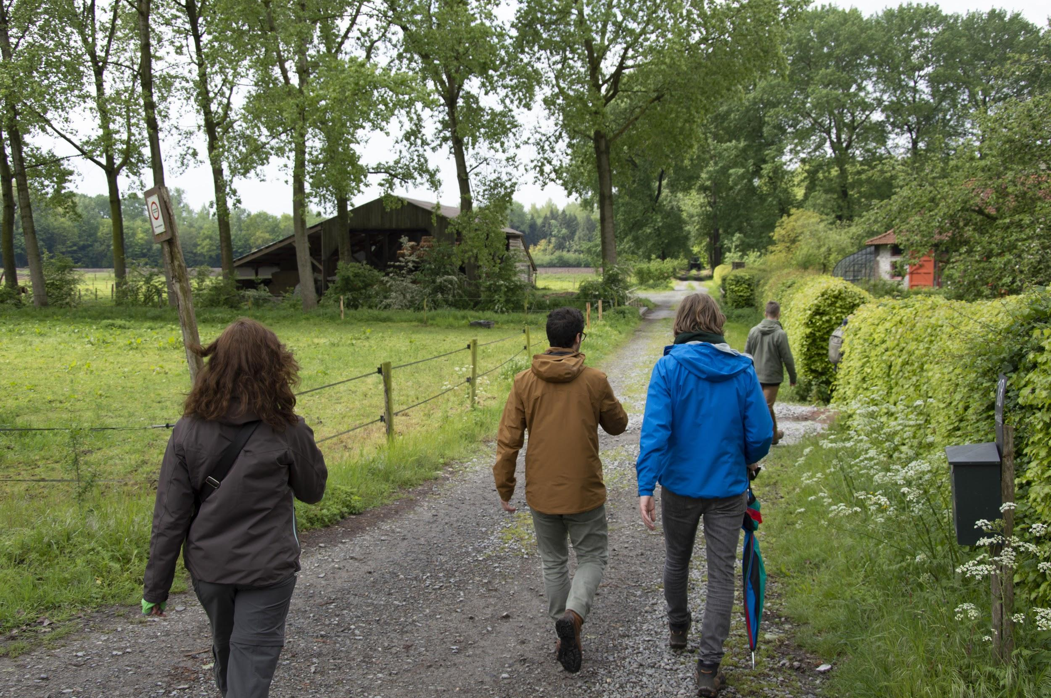

Introduction to the region

The societal, spatial and economic significance of rural estates in Flanders should not be underestimated. They are carriers of regional identities, recreation, culture, heritage, art, ecology and biodiversity, and they make an important contribution to a qualitative and healthy living environment.

Unfortunately, many rural estates are in the process of decline and their preservation is hampered by two specific bottlenecks. Firstly, private property owners indicate that the current policy instruments constitute a barrier to self-proactive activism with their estate. In addition, there are various sectoral regulations that in some cases still focus on optimising separate functions. Secondly, sustained maintenance involves significant financial efforts and the current funding opportunities are insufficient to provide an answer to this. Both the private and the public actors urge the need for new economic drivers in order to become self-sufficient, and there is an urge for a more integrative, international-level approach of rural estates that will result to new ideas.

Targeted policy instrument

Decree on immovable heritage is an overall decree on monuments and landscapes further elaborated in the Decision of the Flemish Government regarding immovable heritage in Flanders. For example, The Decree on Immovable Heritage can set legal important inventories on immovable heritage and provide instruments, permits and premiums to manage immovable heritage. Important possibilities to improve the degree include opening opportunities for non-listed heritage and including aspects of dynamics and transformation of rural estates, for example.

Challenges in the region

The learning cases in Flanders, Belgium focus on the region of the Landscape Park Bulskampveld, which is developed through a formalized partnership between different local and regional organizations as well as higher governments and stakeholders. Working on different levels of cases in this region is useful to both understand the regional impact of the projects and to find detailed information on the management of specific estates.
By selecting four different learning cases and a combination of analysis of private, public and network cases, the Innocastle partner University College Ghent (UCG) hopes to obtain a deeper insight into the importance of the rural estates for the region and the future potential they have.

Action plan

Through the work on the different learning cases, UCG aims to showcase the opportunities offered when these rural estates are approached on a regional level to all the stakeholders in the region. By increasing knowledge, support and inspiration from different stakeholders, study visits and student work, UCG is working towards a broader understanding of the regional level. The action plan will hopefully take this a step further by making the shift from exploring ideas to realizing certain regional cooperation.

Landscape Park Bulskampveld - Cooperation through meetings, projects and site visits
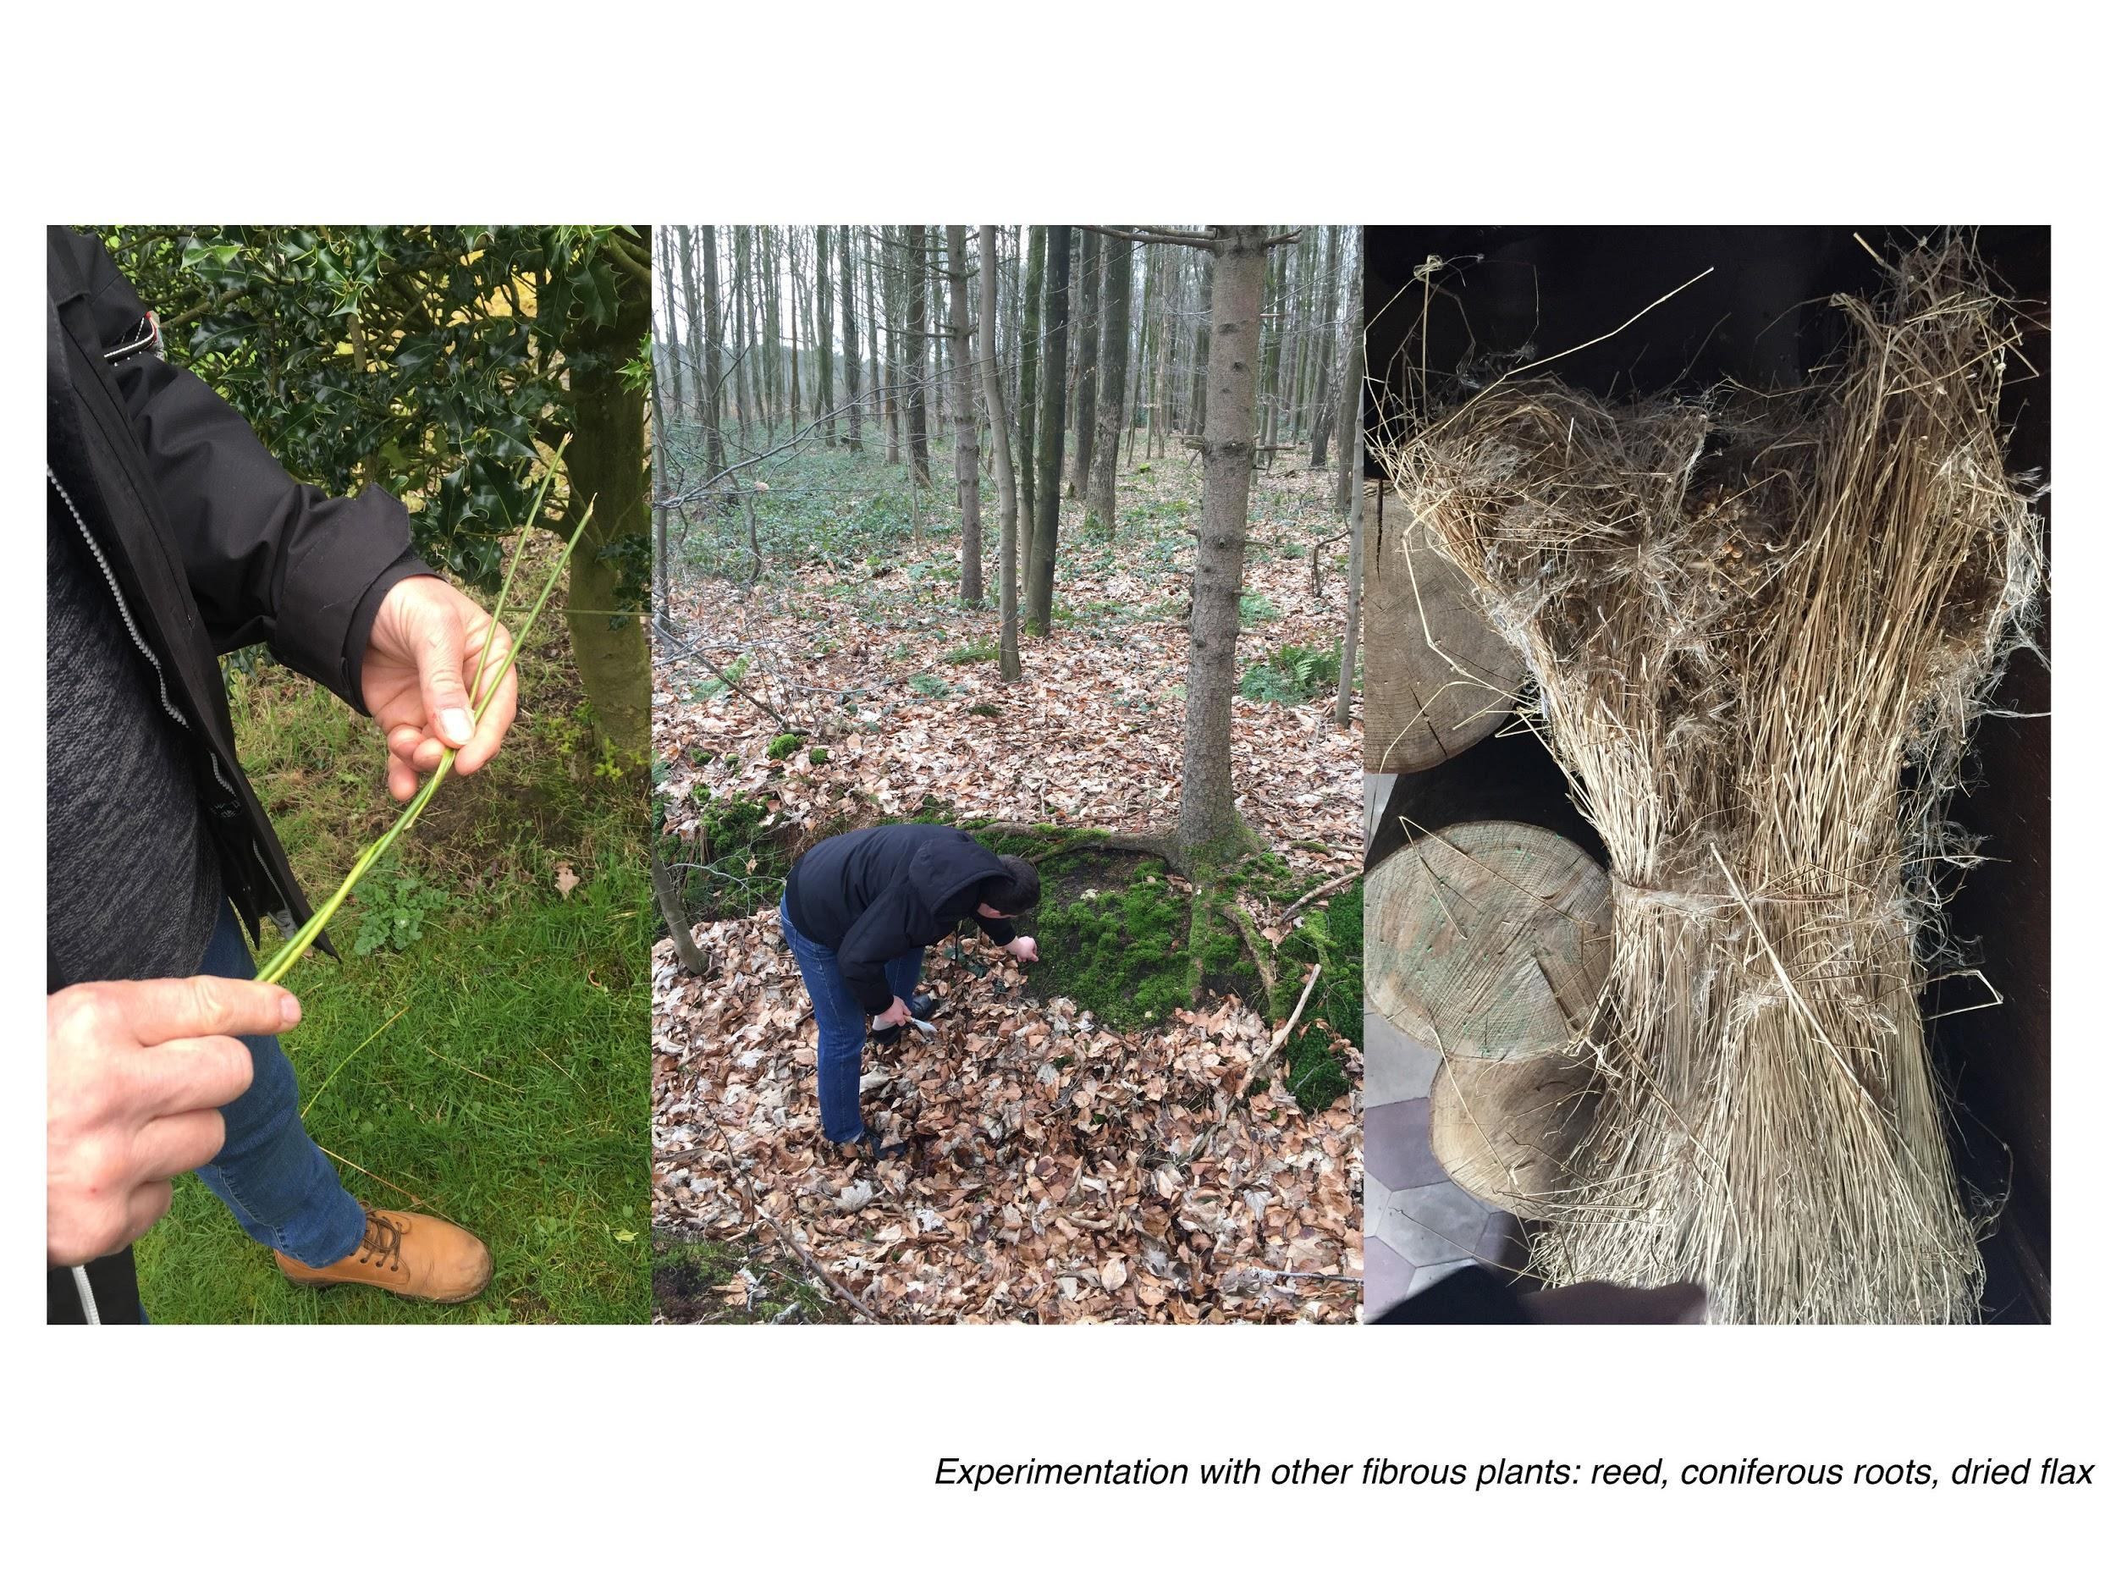

Asset name: Landscape Park Bulskampveld
Location: Municipalities of Oostkamp, Beernem, Aalter, Wingene and Ruiselede - Belgium
Heritage status: parts are protected or inventoried
Visits allowed: yes (it is a region)
Present use: multiple - It is a lively agricultural region used to live, work and recreate

Introduction

The Landscape park Bulskampveld in the south of Bruges finds its roots in the 12th-century agriculture and forestation practices. Its rich history is still visible today as it is now the most forest-rich area of West-Flanders with almost all rural estates still existing today having a huge regional and touristic importance. The developments of the 90 km2 area are underway and executed by 19 different organisations in the region such as the regional office of West-Flanders, different Flemish agencies such as Flanders Heritage Agency, the Nature and Forest Agency and the Flemish Land Agency, 5 municipalities and the different owners of the rural estates.

Issue

The link between the rural estates and the origin of the region is mapped extensively. The current development of the region is well underway, but a contemporary link to the rural estates could be further explored and activated by triggering and supporting owners to get involved and creating support and cooperation on a regional level.

Objective

Cooperation between different owners in the area and the province should be developed through organizing meetings, projects and site visits. We want to trigger and support owners to get involved

Good practice

The area approach from Gelderland, the Netherlands will be implemented to Flanders learning cases.

Gruuthuyse estate - Understanding a unique family-owned estate and its redevelopment
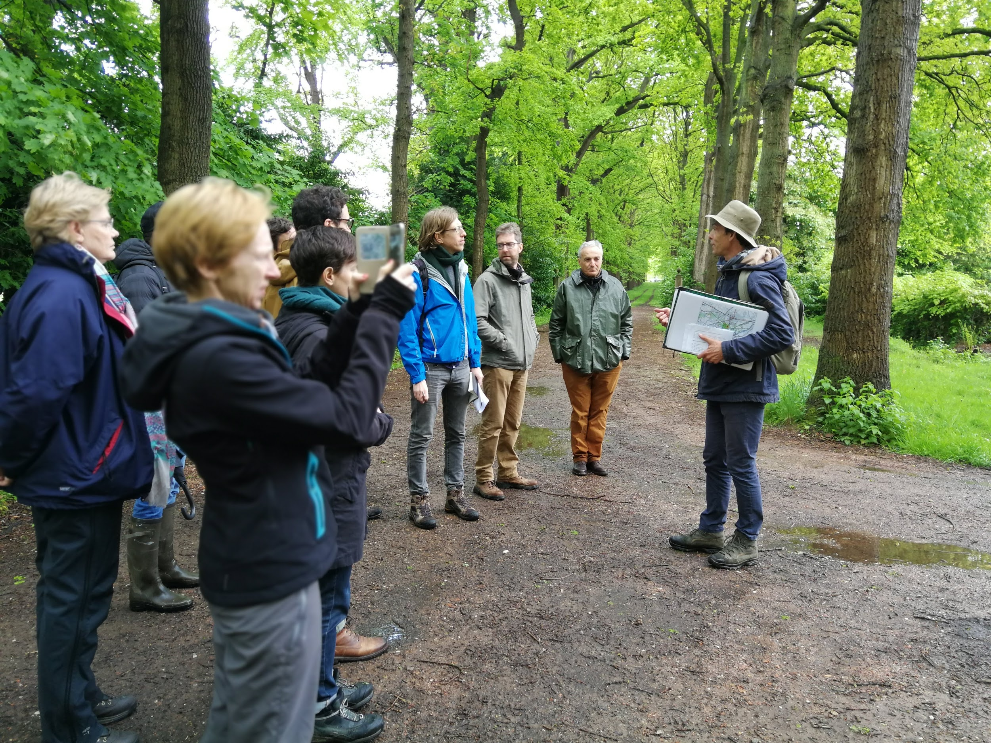
Asset name: Gruuthuyse
Location: Oostkamp, Belgium
Ownership: Private
Heritage status: Both heritage and nature protected
Visits allowed: Yes, guided
Present use: Private residence and family events, farming and nature development

Introduction

Gruuthuyse is one of the largest estates in the region and also one of the very few protected cases. Land management has been an important part of its business model for the last 200 years. With two other estates, Gruuthuyse forms a green boundary to the east of the municipality of Oostkamp. This resulted in a more concentrated urban structure. Oostkamp values the more than 15 rural estates on its territory for their touristic and recreational potential as well as for their spatial qualities. However, a global vision is needed for the future of these domains.

Issue

The historical owning family of the estate is currently looking into a wide range of possibilities for the redevelopment of the whole estate. Aspects that influence decision-making in the redevelopment process need to be further investigated. For instance, the role of immovable heritage, as well as the position of the municipality in the process, needs to be understood.

Objective

The geographical position of Gruuthuyse in relation to the municipality and its current redevelopment quest are common challenges in Flanders and understanding both will provide valuable information on the Flemish level and how the target instrument of the case can influence this process.

Good practice

Although the redevelopment of family estates is of a personal matter, it cannot be disconnected from the regional perspective nor the community directly connected to the estate. The value of the local community has become clear in the Luna Castle in Spain and the Hay Castle in the United Kingdom, and these example cases could be used to as an inspiration at Gruuthuyse estate as well.

Lippensgoed domain - Provincial domain used for recreation, education and nature development
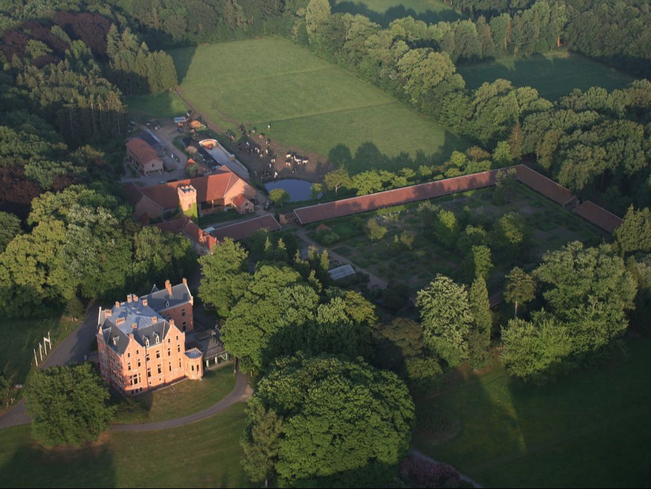
Asset name: Lippensgoed
Location: Beernem, Belgium
Ownership: Publically owned, managed and used. Multiple owners.
Heritage status: Consolidated heritage and nature protected
Visits allowed: Yes, the park is always open, the building has opening hours.
Present use: Provincial domain ‘Bulskampveld’, working farmstead, visitor centre, restaurant, nature development.

Introduction

The estate is situated in the center of Landscape park Bulskampveld and functions as a gateway to the region. It is a provincial domain including a working farmstead, a visitors center, a restaurant and a herb garden. Primary stakeholders are the different institutions of the province, the Flemish Land Agency, the Flemish Nature and Forest Agency and the general public. Lippensgoed is the largest and the most complex estate in the Landscape park Bulskampveld and the biggest estate in the Province of West-Flanders as well.

Issue

The estate's function as a gateway for the region is valuable but the potential of a connection and interaction with other estates in the region is not yet activated.

Objective

The province has set for itself nature, recreational and educational targets with the estate and it would be interesting to understand how the heritage aspect influences these three main targets. Exploring the potential of a connection to private estates in the region would be valuable.

Good practice

Regional tourism strategy from Gelderland, the Netherlands, will be used as an area approach at Lippensdgoed.

Wildenburg estate - Value and future of a family-owned estate
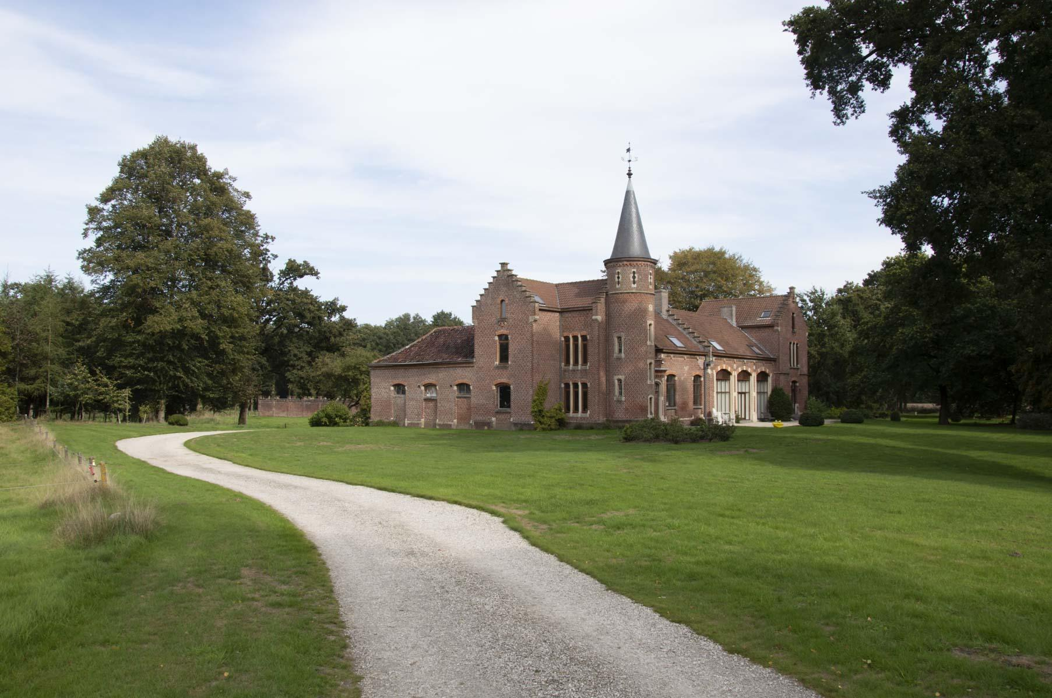
Asset name: Wildenburg
Location: Wingene, Belgium
Ownership: Privately managed, owned and used.
Heritage status: Consolidated heritage
Visits allowed: Occasional guided visits.
Present use: Private residence

Introduction

Wildenburg is a typical Flemish estate in a rural context, with the exception that the main building has disappeared. The coach house is now the main building. The estate does not generate a large income as its mainly used as a private residence for the owner. The structure of the park is in good condition. A spatial implementation plan for a part of the municipality has set the boundaries for redevelopment.

Issue

The Wildenburg estate is mainly used as a private residence. Succession through heritage is uncertain and redevelopment interest from external partners is currently low. Does this reflect the value of the domain? The spatial implementation plan is very clear in what is possible and what is not but not everybody agrees with the generated possibilities.

Objective

Understanding the value of this domain and the importance of the spatial implementation plan because it can provide valuable lessons about the future of similar estates in Flanders Decisions on the development regulations to ensure it’s future will be investigated and it will be vital to understand how different stakeholders perceive these regulations.
We will furthermore explore alternative development possibilities through the organisation of living labs.

Good practice

Margiloman Hagiesti in Romania is going to be used as inspiration because certain similarities in the challenges exist between the two estates. Other estates in Romania which are used for festivals and summer schools are also interesting opportunities for Wildenburg.

