Learning cases Romania

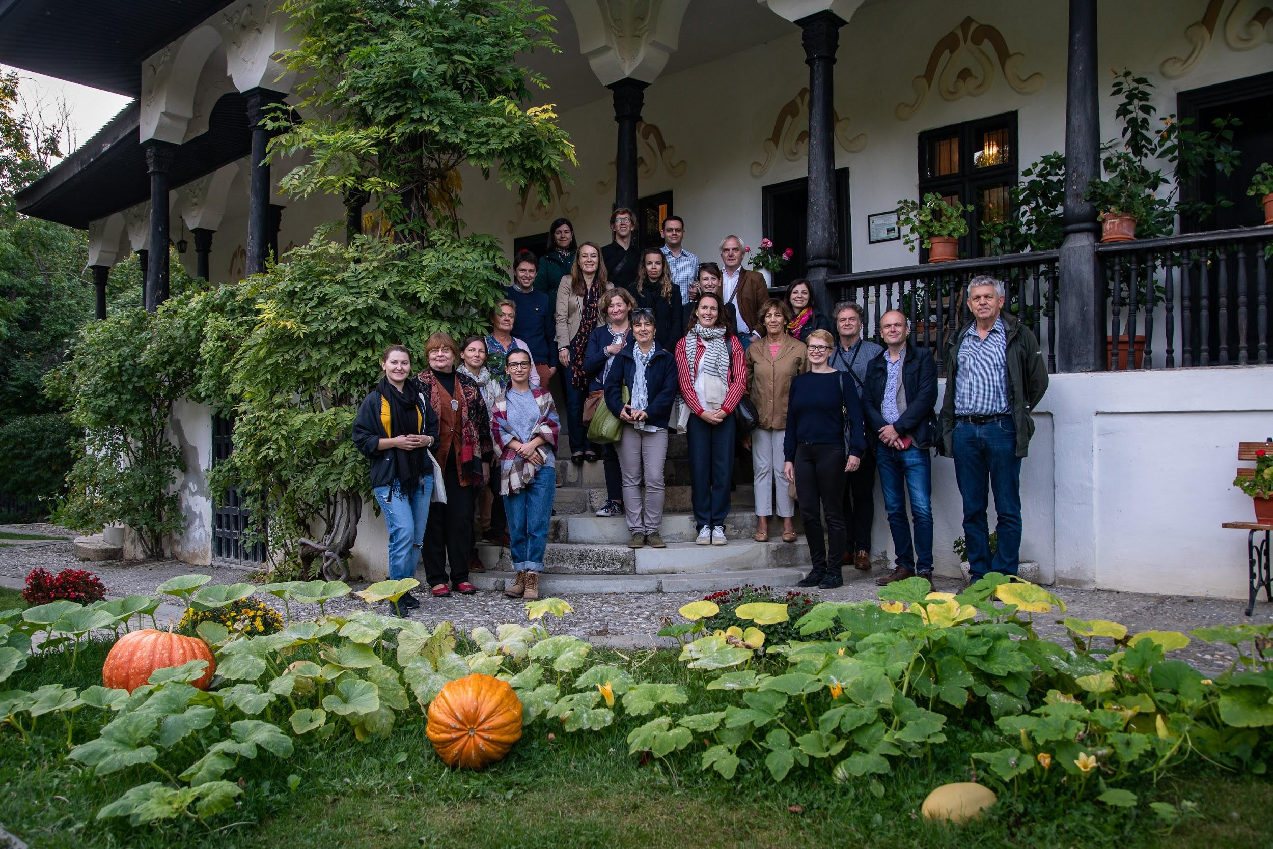

Introduction to the region

Heritage in Romania has the potential to perform as an economic and social catalyses in many underdeveloped and poor areas, where most population practices subsistence agriculture. Heritage could create jobs, increase tourism, promote local heritage and traditions, and help build more cohesive and resilient communities. An important segment of Romanian cultural heritage is represented by rural estates found in rural areas. These rural estates, together with their gardens, annexes, forests and agricultural areas form coherent ensembles that can become important factors in local, regional and national regeneration.

Although distributed in a balanced way across Romania, cultural heritage in Romania is currently in very poor condition. According to the Ministry of Culture, 75% of the monuments in Romania are in bad condition, with 35% being badly damaged. Heritage is currently threatened by climate and environmental changes well as by unauthorised human intervention, and a more integrated, inclusive and coherent approach is required to bring the Romanian cultural heritage to fruitful actions.

Addressed policy instrument

The addressed policy instrument, the Regional Operational Program (ROP) 2014-2020, / Investment Priority 5.1: ‘’Preservation, protection, promotion and development of the cultural heritage and identity’’, aims to stimulate the local economy by improving the overall condition of heritage sites in Romania. As such the axis can finance the restoration and touristic promotion of built heritage. Like all other policy instruments targeted by Innocastle, Priority 5.1 needs to be more correlated to other regional development strategies which include or affect cultural heritage, reflect stakeholders’ needs and to develop comprehensive evaluation criteria for the economic impact on local communities.

Challenges in the region

The main challenges in the Center Region are the continuous drop of demographics throughout the territory due to migration of young and qualified people and the increase of poverty in towns and rural areas due to polarization of the economy in the big cities and their surroundings. From a cultural point of view, an important challenge is the continuous change of the ethical structure, which affects the multiculturalism of the region, one of its main assets. The cultural diversity, as well as the rich nature, make the Center Region one of Romania's best-known areas for tourism, an economic sector that is envisioned gain a more important role in regional development.

The built heritage is one of the main expressions of the region’s cultural diversity but it faces several threats due to the faulty national protection system. In this context, the regional network of historic castles, manors and estates, former rural catalysts for local development, struggle to reinvent themselves. Main challenges include estate fragmentation, poor collaboration between stakeholders and the lack of a coherent framework. Through Innocastle, the National Institute of Heritage aims to improve several policy instruments in order to increase the role of heritage in the regions and to change the national mentality from heritage as a cost to heritage as an investment in regional development.

Action plan

The National Institute of Heritage started by targeting the Regional Operational Programme 2014-2020, the main source of financing for heritage restoration in Romania. Through Innocastle, the partner hopes to increase the quality of the restorations financed through this programme and to switch the focus from mere restoration to a more sustainable approach, including business diversification and valorisation of the site.

Moreover, the partner is also looking into the National Restoration Program (PNR) and the Historical Monuments Stamp Duty (Timbrul Monumentelor Istorice - TMI) run by the Ministry of Culture through the National Institute of Heritage (INP). Specifically, the focus will be on engaging stakeholders throughout the entire restoration process financed by PNR, in order to build a sustainable plan for the management of the buildings after they have been restored, through several activities that can be financed through TMI.

The Teleki Triangle - A historical landscape approach as a new way to conduct research
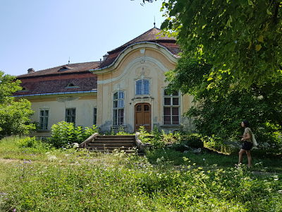
Assets name: Teleki Triangle (Gornești castle ensemble, Dumbrăvioara castle, Glodeni manor)
Location: Gornești, Dumbrăvioara, Glodeni, Mureș county
Ownership: Private, Mixed and Public - this is based only on the ownership of the listed heritage items and the visible parts of the park. Actually, based on historical fragmentation, all estates have mixed ownership.
Heritage status: protected
Conservation status: good - medium.
Visits allowed: Yes (Gornești), No (Dumbrăvioara, Glodeni)

Introduction

Teleki triangle reunites three historic estates, each comprising the castle, its park and a crypt. Gornești and Dumbrăvioara are private property, Glodeni is public property with the intention of being sold in the near future. The three estates belonged to the Teleki family, one of the important aristocratic families in Transylvania.

Among them, the castle in Gornești is the oldest and most significant for the family. The estate was given to Mihály Teleki, chancellor of Transylvania in the second half of the 17th century. The family transformed the medieval citadel into a Baroque castle in the following centuries. Comprising several historic layers, the former residence, as well as the park, a series of annexes and the family crypt can still be found on the property and in the nearby area. During communism, the village expanded on the former estate, altering its structure. Several remaining annexes (granary, stables) are located outside the current castle grounds, hidden behind modern buildings. After receiving back the property several years ago, the family founded an NGO dedicated to revitalizing the estate. Today, it functions as a museum and event center and is open to the public.

The history of the Teleki estate in Dumbrăvioara began in the late 18th century, when Samuel Teleki, chancellor of Transylvania and founder of the Teleki library in Târgu Mureș, started building a manor. The final building phase was led by Teleki Samu in the early 20th century, who built the central volume, linking the two wings. Samu Teleki was a famous explorer who brought back many trophies from his expeditions, which he exhibited on his estates. In communist times, it was transformed into a school, then given back to the family several years ago. Recently, the castle and part of the park were bought by a private investor who wishes to transform the estate into a medical retreat with cultural and leisure features. The rest of the park belongs to the local community. The park is not listed, although it still has some visible heritage features.

The estate in Glodeni previously had two manors, but one was demolished after WWII. The remaining estate was extremely fragmented in order to offer room for the development of the village. Today, the existing manor houses a facility for people with special needs and is inaccessible to the public. The family crypt, located in the present-day cemetery, can be visited. It is abandoned and in a poor state of conservation. The park has been lost and only a small garden remains in front of the manor.

Issue

Fragmentation of the historical estates, as well as a complex ownership structure, remain the main challenges within the region. The cultural landscape has been deeply transformed in the last century and especially during communism - the Mureș river was channelled, changing its course, the villages changed their structure, and new houses were built on the domains. Also, new structures, necessary for the new uses of the castles and manors, were built on the estates. The three crypts that were once an important part of the estates - having a strong visual connection with the castle - are now disconnected from the estate, as they are located far from the manners, either on a hill or in the village cemetery. The visual connection has been severed and the structures are hard to maintain.

Owners of the estates are hesitant to cooperate, and there is a lack of knowledge on how to finance and approach historical monuments in order for them to function together. This lack of cooperation leads to creating scenarios with overlapping functions and services, which further lead to the estates competing against each other in a non-sustainable way. Instead, through good cooperation among all owners and stakeholders, they can develop complementary services, making these estates more attractive to a wider audience and create recurrent visitors.

Objective

We wish to enhance collaboration between the owners of the three estates and local and regional stakeholders. Our aim is to use a territorial approach to generate a common framework for the estates and the neighbouring areas, in order to create an integrated approach from both the functional point of view and the financing needed for restoration. We also wish to promote the concept of programming in order to create a sustainable connection between the estates and develop an offer that attracts a recurring and diverse public.

The plan here is to test the landscape approach previously implemented in the Netherlands. To be able to do this, more information on the connections with different stakeholders needs to be gained. Valuable would be to know where to find funding for research, rehabilitation and transformation of the estates. Administration and business models on how to sustainably reuse rural estates should be gained through participation in Innocastle.

Good practice

Programming, visiteering, The ARCHÉ summer school, the territorial (landscape approach), the Ambulance for monuments can all be possible good practices used in the area in order to restore structures in urgent need of conservation. Additonally, the Middachten example can be used as an example framework for the cooperation between public and private owners.

Rhédey Castle - Example of multiple financing

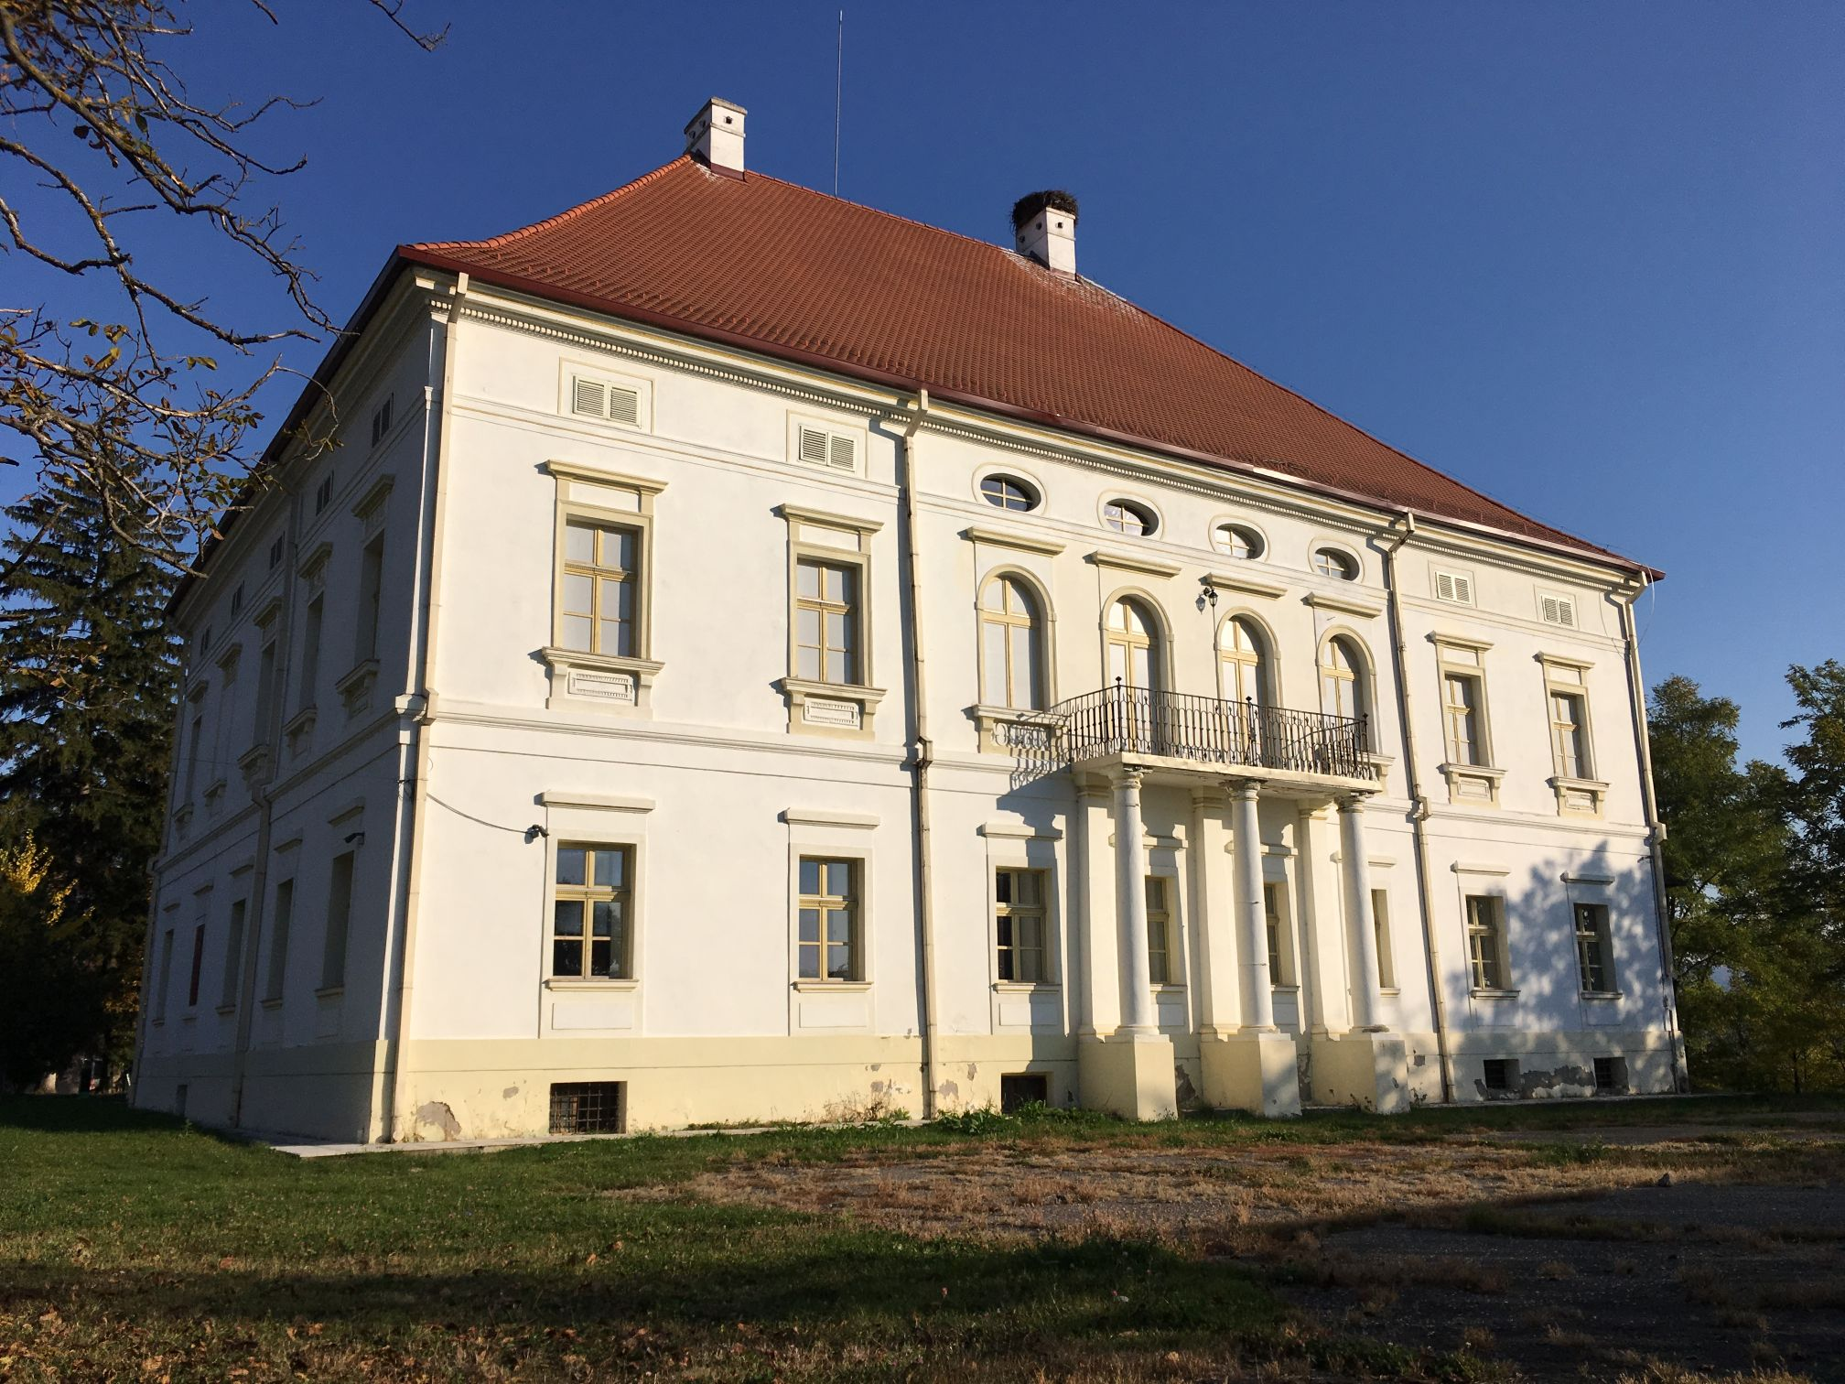
Asset name: The Rhédey castle
Location: Sângeorgiu de Pădure, Mureș county
Ownership: Public
Heritage status: protected
Conservation status: excellent (the castle), poor (annexes and park)
Visits allowed: Yes
Present use: Museum

Introduction

The estate has several stages of construction and the castle gained its current form in the early 19th century. The castle was restored through the National Restoration Programme between 2009 and 2015. The local authorities bought neighboring plots to recreate the historic park and also have plans to restore the annexes. Today, the castle houses a local museum and community spaces and is open to the public. One of the key historical figures linked to this estate is Countess Claudine Rhédey von Kis-Rhéde, the great-great grandmother of Queen Elisabeth II of England. The restoration of the castle created the premises for the local authorities to further access funds and also invest resources from the local budget in order to set up the exhibits and think of ways in which to further valorize the estate.

Issue

The quality of the architectural and restoration interventions should be improved, as damage can already be seen on the castle. Future interventions on the nearby buildings and on the park should take into account the lessons learnt from the restoration of the castle. Also, the historical center of the town has multiple heritage values, grouped close to the castle: the nearby church, several historic houses, traces of the park. The restoration of the castle can act as a catalyst for further projects that can revitalize the area. For this to happen, local authorities need to act strategically in order for their efforts to have a larger impact.

Objective

One of the aims of this learning case is to study how this project went through all the stages within the National Restoration Programme: from concept, through tenders, execution and current management. The second step will be to study how local authorities assessed diverse funding for complementary projects.

Good practice

Lessons learned from the local administration’s experience with diverse funding programmes.

The Bornemisza Estate - Several layers of history - enhancing collaboration between stakeholders and create a sustainable plan for the estate
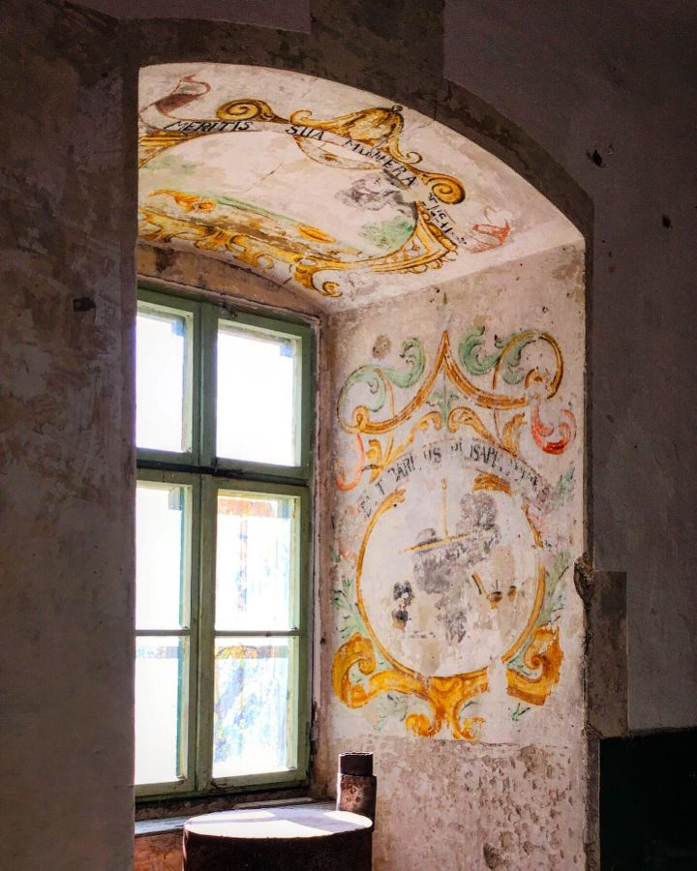
Asset name: The Bornemisza estate - The Bornemisza Castle Ensemble + Gurghiu archaeological site
Location: Gurghiu, Mureș county, Romania
Ownership: public (two public county administrations)
Heritage status: protected (Grade A - national importance)
Conservation status: good
Visits allowed: Yes
Present use: unused

Introduction

Bornemisza Estate includes multiple historical elements within its surroundings – castle, park, chapel, archaeological site and the citadel. The castle has a project intended for ROP. The historical assets are divided by several public owners: the castle belongs to the Mureș County Council, while the park and the citadel located on the nearby hill belong to ...

While the citadel dates back to the 14th century, the castle’s history began in mid 17th century, when Prince Rákóczi György I built a hunting manor (with a park) in Renaissance style at the base of the hill where the citadel is located. Further on, the estate passed to the Bornemisza family, who expanded it and also built several industrial facilities (porcelain factory). They also redesigned the park in Romantic style. In the 19th century, the estate passed to the state and became a hunting manor for Kronprinz Rudolph II of Habsburg. After his death, it was transformed in 1893 into a professional forestry school, the surrounding park being a valuable training resource. In 1970, when the new building for the forestry school was finished, the castle was transformed into a museum, which also housed several of Samu Teleki’s hunting trophies (brought from the castle in Dumbrăvioara). In 2008, the estate was transferred to the Mureș County Museum.

Issue

In order for the entire estate to be properly revitalized, its restoration and interpretation must take into account the multiple historical values that can be found in both the citadel and the castle and its park. Fragmentation of the historical estate and division between owners remains an obstacle as they struggle to find a suitable framework for cooperation. The existing restoration, transformation and activation project that focuses on the castle alone is of poor quality and is not sustainable. This project was conceived for the former financial exercise and was meant to transform the castle into a cultural facility with a hotel and spa. It did not receive funding and the County Council is currently looking to improve it.

Objective

The objective of this learning case is to enhance collaboration between stakeholders and create a sustainable plan for the estate. One solution would be to integrate the former function of the castle - the forestry school - into the future revitalization scenario, creating a regional training centre for the research and restoration of historic parks. Given the multitude of historic parks in need of skilled human resources, this scenario would be sustainable and would offer substantial benefits to the area. For this to happen, there is a need to reinvolve the Ministry of Education, the former owner of the castle during the modern part of the forestry school’s functioning, who gave up the property.

Accessing multiple funding sources for a framework of complementary projects - as is the case for the Rhédey castle - can provide resources for this type of complex project that is both sustainable from a functional point of view and also integrate the values offered by the way in which the estate was used.

The aim of the learning case is to study how PNR can be complementary to other funds and to see how the programme’s impact on restoration works can be improved (also through the use of the Historical Monuments Stamp Duty for research and local activation). Cooperation between owners in order to improve the quality of restoration works is needed. Rural estates need complex finance schemes and new investments that include different types of national and international funds.

Good practices

Stakeholder involvement and negotiation - a period dedicated to dialogue that will facilitate the creation of a good plan for the entire estate. The Middachten learning case - example for a framework of cooperation between public partners in regard to historic domains in public property.

