Good Practice template

- General information
Title of the practice | SWEDEN'S FIRST AGRIVOLTAICS SOLAR CELL PARK - AGRICULTURE AND SOLAR CELLS IN CO-EXISTENCE.
Does this practice come from an Interreg Europe Project | NO  [Technical: Good Practices outside the IR-E projects relevant to the topics and validated by the Policy Learning Platforms experts will also be included in the database]

In case ‘yes’ is selected, the following sections appear:

Please select the project acronym | ENERSELVES

Specific objective | Drop-down list of the 6 specific objectives  [Technical: In case a project is selected, the specific objective is automatically completed]
Main institution involved | [Technical: The name of the institution and location of the practice are per default those of the practice author. They remain editable.]
Location of the practice | Country | Drop-down list
 | NUTS 1 | Drop-down list
 | NUTS 2 | Drop-down list
 | NUTS 3 | Drop-down list

- Detailed description
Detailed information on the practice | [1500 characters] Please provide information on the practice itself. In particular:  Outside Västerås,Ulf Andersson and his family run Kärrbo Prästgård, which since the early summer of 2021 has Sweden's first Agtivoltaics solar system on its farm. This is the first time in Sweden that a so-called agrivoltaic solar cell system has been installed and evaluated, both in terms of solar production and cultivation.  In addition to this system, a small traditional solar park is also set up to be able to compare the efficiency of the two. Even a reference surface with grass completely without solar panels will be cultivated to measure the differences in vegetation and moisture.  Agrivoltaic systems presents several advantages over traditional ground-based photovoltaic systems: higher electricity yield, crop yield and water savings as compared to common practices. The combination of revenues can lead to high land use efficiency and shorter payback time.  The aim is to investigate how it is possible to combine agriculture with solar farming in Sweden now that electricity demand is expected to increase.  As a result of Covid-19 pandemic, Swedes have started to have more interest in their properties and homes which occurred with more electricity consumption during quarantine. A pattern was discovered among citizens regarding own electricity consumption and the interest in investing in solar energy in industries, farms, private homes and apartments. Consequently, to these reasons Ulf had an interest in investing in agrivoltaics.  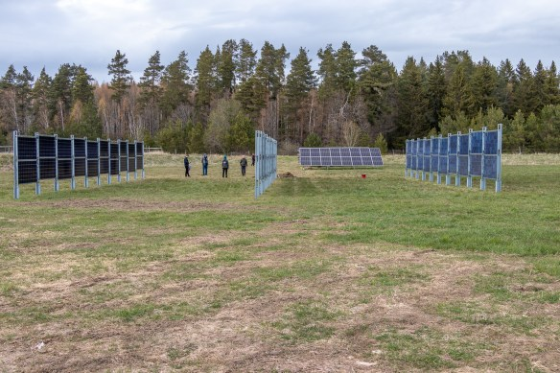
Resources needed
Timescale (start/end date) | June 2021 –/ongoing
Evidence of success (results achieved) | Agrovoltaics on agricultural land would provide more electricity than Sweden's annual needs and even increase the harvest in dry weather, as calculations from Mälardalen University show. Now the researchers can reveal the first promising results: including increased harvest in drier weather. The results show that agricultural land is well located in Sweden and there it will be cheapest to build solar parks, and there will be no problems with shading.
Difficulties encountered/ lessons learned | The Swedish Environmental Code is an obstacle to the expansion of photovoltaic parks on agricultural land. Given the large future need for electricity, the production of solar should also begin to be regarded as a significant public interest as agriculture and solar cells can coexist.
Potential for learning or transfer | Energy Agency of Southeast Sweden has prepared for a webinar on the 20th of April where hospitality industries from the southeast Region presented how they worked with self-consumption during the pandemic and how they due to that were affected. The participants have spoken about their positive experiences in investing in solar panels and about the well to follow this evolution of solar panels. Many participants have shown a big interest in learning more about agrivoltaics and in the well in investing in such an installation in order to combine agriculture and self-consumption.  Due to the covid-19 pandemic followed by higher electricity consumption during quarantine which have hit globally this good example can be spread to different regions in order to engage citizens in different countries to have more interest in their properties and farms to invest in such installations.  It is even proven that high electricity prices during the winter will continue to increase.
Further information | https://www.mdu.se/forskning/forskningsprojekt/framtidens-energi/utvardering-av-det-forsta-agrivoltaiska-systemet-i-sverige
Contact details [Technical: the contact details will be visible only to “Policy Learning Platforms registered members”
Name
Organisation
Email
Expert opinion | [500 characters] [Technical: to be filled in by the Policy Learning Platforms experts]

