Penta helix online platform project idea

Creating conditions for effective cooperation of penta helix model actors in the Prešov Self-Governing region (PSGR) through an electronic platform for creating innovative solutions in the Prešov region.
The idea of the initiative - to put innovative know-how into practice quickly, efficiently and transparently to create an electronic platform for cooperation so that companies with innovative potential can increase their competitiveness and innovative potential quickly without long administrational burden and online in the difficult Covid 19 times.
SMEs with innovative potential apply for a website, in what area and what they would like to solve (innovate) – researchers, patent owners, skillful students, creative citizens etc. will apply online on SMEs requests and the company will choose solution that will interest them. Administrator of the platform- PSGR office (public administration institution) will have also the tool for assessing the project ideas if the projects has potential to be innovative and competitive.

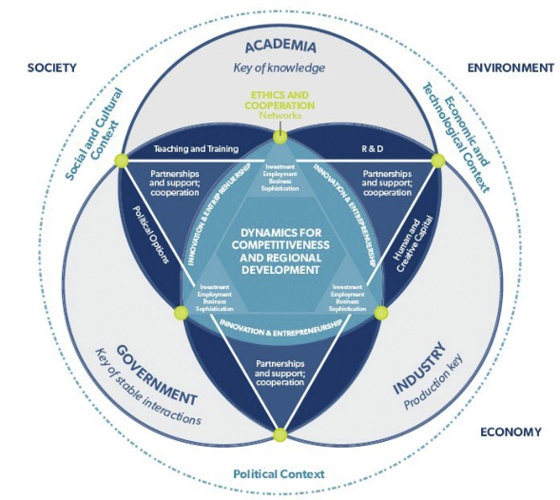
International character - researchers from other countries of EU can also be involved, but beneficiaries (SMEs) must be from PSGR in order to ensure the main goal of the initiative - economic growth of the Prešov region, keeping smart people in the region and attracting more sophisticated investments fromforeign countries in the near future. This platform will be the integrator of innovative know-how in the region so more effective, cooperative and competitive innovation ecosystem in PSGR could develop. This strategy has potential to restart the regional economy in times of coronavirus crisis.
Funding - the PSGR office (public administration institution) will contract the successful problem solving entity (researcher, etc) and will pay him - part of the amount could be reimbursed as part of the implementation from the regional fund (50 %), part of the amount (50 %)will pay SME from its own budget. After the implementation if it will be a successful project the money which were paid by SMEs will be refunded by the Regional PSGR fund.
Objective: Implementation of the concept of "Data-driven innovative regional development" into practice will strengten more effective cooperation between SMEs, R&Ds, universities, citizens and public administration within the penta helix model as a prerequisite for increasing the innovative potential, economic growth and quality of life in Prešov region.

Prešov Self-Governing region office (PSGR) is a public institution with competences to coordinate regional development in Prešov region. It is the first region in Slovakia, which cooperates with World Bank and
European Commission directly on innovative projects regarding regional development in “Catching-up Regions Initiative.”

PSGR has also Innovation Partnership Centre which with cooperation with other key regional stakeholders
as Prešov University, Cluster in Robotics and Automatisation, IT Valley Cluster and innovative firms creates
innovative ecosystem in the region.

PSGR for example has implemented innovation strategies for SMEs support such as regional innovation
vouchers scheme in the region. PSGR has well developed GIS system with Geoportal, pilot activity in Slovakia,
the crucial data-driven regional development system which enables to bring important data for key
stakeholders and public more efficiently with synergy effect. PSGR is also called “SMART region PSGR.” In this
year PSGR started to implement new SMART policies and strategies across the region. It emphasizes its
actions not only in economic growth, but also in increasing its citizens quality of life. Indicators such as Social progress index are for PSGR as important as for example regional GDP.

