Interreg Europe progress report template

1. Summary of project activities

1.1 Overview of project outputs (automatically filled in by the system)
Code | Title | Target (AF) | Achieved
RC087 | N° of organisations cooperating across borders
RC084 | N° of pilot actions developed jointly and implemented in projects
OI4 | N° of policy instruments addressed
OI5 | N° of interregional policy learning events organised
OI6 | N° of good practices identified

1.2 Activities of the current reporting period

Exchange of experience

Activities as originally planned (from application form, example below)

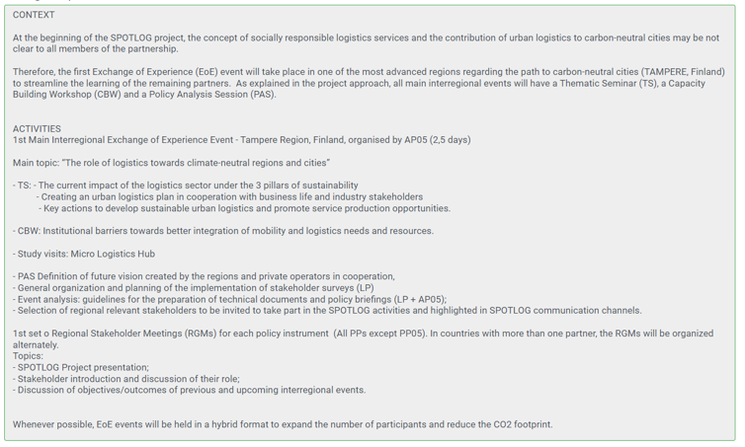

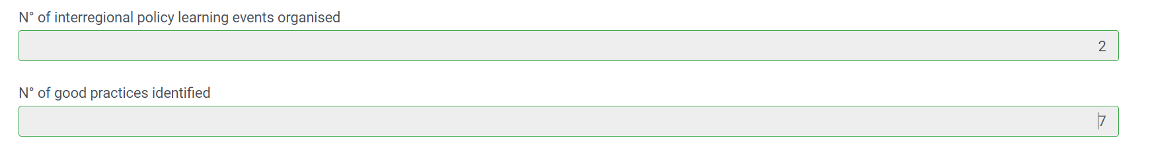

Activities completed during the reporting period
Please describe in detail the activities related to the exchange of experience process. For each interregional event, details such as place, date, number of participants and topic addressed should be provided.

[3000 characters]

Please indicate the number of interregional policy learning events organised during the period (in line with the above description of the completed activities)
N° of interregional policy learning events organised

Did all partners participate in the main interregional policy learning events? YES / NO
Please explain which partner(s) could not join and provide a justification?

[3000 characters]

Please indicate the number of good practices identified during the reporting period
N° of good practices identified

Pilot action (only if applicable)

Pilot action 1

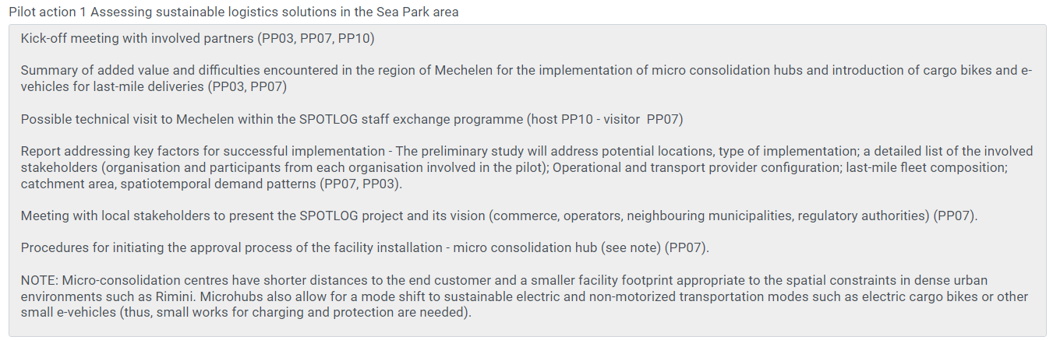
Activities as originally planned (from application form, example below)

Activities completed during the reporting period

Please describe in detail the activities related to the pilot action

Please click in this box when the pilot action is completed:

[3000 characters]

Pilot Action 2

…..

Communication

Activities as originally planned (from application form, example below)

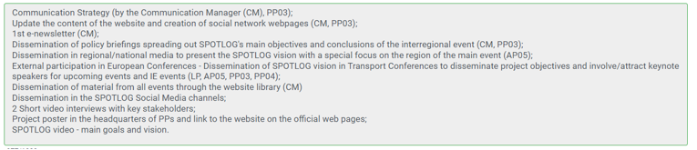

Activities completed during the reporting period. Please describe in detail the activities related to communication.

[3000 characters]

1.3 Changes from the original plans
Please describe and justify any changes from the original work plan. In case of delays, please explain the measure envisaged to catch up with the original time plan.

[3000 characters]

2. Insight into project’s results

2.1 Overview of project results (automatically filled in by the system)

Code | Title | Achieved | Performance
RI2 | N° of organisations with increased capacity due to their participation in project activities
RI3 | N° of policy instruments improved thanks to the project

2.2 Overview of policy instruments (automatically filled in by the system)

Number | Name of the policy instrument | Partner(s) addressing this instrument | Involvement of the policy responsible authority | Country | First policy change reported in

1

2

3

4

5

6

7

2.2.1 Partner policy report (policy partner report)

TAB 1 – Details on policy instrument 1

1. General information

Name of policy instrument addressed:
Reporting period

Policy instrument addressed by

Geographical scope
Please indicate the geographical scope of this policy instrument.
Country | select from drop-down menu
NUTS 1 level | select from drop-down menu
NUTS 2 level | select from drop-down menu
NUTS 3 level | select from drop-down menu

2. Policy improvements
Has the project succeeded in improving this policy instrument? YES / NO
If YES,
Please indicate the nature of this improvement (see also section 4.3.1 of the programme manual):
New projects financed
Change in the management
Revision of the instrument
Please describe in detail the policy improvement achieved thanks to the project.

[3,000 characters]

Is a pilot action at the origin of this policy improvement? YES / NO
If yes, please explain how the pilot action contributed to improving the above policy instrument.

[2,000 characters]

(If no,) please explain why this improvement would not have happened (fully or partly) without the Interreg Europe project: i.e., what is the link between the improvement and the activities organised within the project? Which lessons learned from the project were at the origin of this improvement? Please name the practices, activities or other content source which provided the inspiration for achieving this result.

[2,000 characters]

NOTE: Once a policy improvement is validated, the above fields of section 2 ('policy change') are fixed for all future reports. Instead, the following section is inserted before the field dedicated to the funds influenced:

Please describe any update on the policy improvement previously reported (see above) and/or any additional improvement to this policy instrument
[2,000 characters]

 | Current period (EUR) | Cumulative (EUR)
If applicable, please estimate the amount of funding influenced by the project. | 0.0 | 0.0

Please explain how the above amount was estimated.
[1,500 characters]

Territorial effect
Please describe the effect of the above policy improvement in the territory (e.g., beneficiaries concerned, results achieved in terms of increased competitiveness, cleaner environment, or more inclusive society).

[2,000 characters]

TAB 2 – Reporting on the learning process (core phase) / Monitoring results or action plan (follow-up phase)

A. Insight into the learning process (core phase)
Please list the main activities organised in your region contributing to the individual and organisational learning (e.g., stakeholder group meetings, activities within your own organisation) during this period. Who are the main stakeholders involved?

[2,000 characters]

Please describe more specifically the involvement of the associated policy authority during this period.

[2,000 characters]

Please summarise how you region contributed to the content of the interregional activities and benefited from it during this period.

[2,000 characters]

A. Insight into results or action plan monitoring (follow-up phase)

Please summarise the main activities related to monitoring the results or to implementing the action plan in your region during this period. Please also explain whether the stakeholders (including the associated policy authority if relevant) are involved in these activities?

[3,000 characters]

B. Achievement
Organisations with increased capacity due to their participation in interregional cooperation
Please indicate in the table below all organisations that were involved in the project as well as the result of their questionnaire on ‘organisations with increased capacity’ (see appendix 2 of the manual)

Name of the organisation | Role in the project | Increased capacity | Upload questionnaire

YES / NO

Remove

Remove

Remove
Remove
Remove
Remove
Add new stakeholder
TOTAL
TOTAL YES

Please indicate any further comments on the outcomes of the survey (i.e. organisational learning achieved within the project)?

[2,000 characters]

TAB 3 – Involvement in the Policy Learning Platform
During the reporting period, did you contribute to any of the Policy Learning Platform activities (for example contribution to policy briefs/ stories, speaker in an event, peer in a matchmaking/ peer review). YES/NO

Please specify how ___________________

During the reporting period, did you use any services of the Policy Learning Platform? YES / NO
Please indicate which services you used: (multiple choice)
Find policy solutions (for example use of the good practices database, policy briefs, stories, learnings from events):
Please specify which tool / publication you used__________________

Meet the community (for example participation in thematic workshops/ webinars/online discussions, finding contacts through the community)

Please specify ___________

Get policy advice (through hosting a peer review/matchmaking session or using the policy helpdesk)
Please specify which policy advice support you used___________________

If relevant, please indicate what benefits you gained from using these services: (multiple choice)
- Increased professional capacity
- Cooperation with new organisations / projects
- Other

Please further explain the benefit gained (if any)

[1,000 characters]

Do you have any suggestions on the Platform activities (e.g., topics to be covered, services to be offered)

[1,000 characters]

+Add new policy instrument = Creation of TAB 4

TAB 4 - New policy instrument

1. General Features
Name of the policy instrument

Please describe the main features of this policy instrument.

Is this instrument an Investment for jobs and growth goal programme (i.e. national or regional operational programme)? | YES / NO
Is the authority responsible for this policy instrument included in the partnership? | YES (select the partner from the drop-down menu) /  NO
(In case of NO) Please name the policy responsible authority for this policy instrument

Please indicate the geographical coverage of this policy instrument.
Country | select from drop-down menu
NUTS 1 level | select from drop-down menu
NUTS 2 level | select from drop-down menu
NUTS 3 level | select from drop-down menu

2. Policy improvement
….. as above

2.2.2 Name of new policy instrument

……

PR6 template (action plan)
In case no improvement is reported in PR6 (‘no’ answered to the following question in section 2: ‘Has the project succeeded in improving this policy instrument?), the following should appear below this question:

3. Action Plan

Since no policy improvement is achieved by the end of the core phase, a brief action plan has to be produced.

Does this action plan address the present policy instrument? YES/NO

What kind of improvement(s) do you envisage for this instrument?

New projects financed through the instrument

Change in the management of the instrument

Revision of the instrument itself

Please further explain the expected improvement deriving from the action?

[1,500 characters]

Please describe the main action envisaged to achieve result in your region before the end of the project.
Action
Name of the action: ________________
Relevance to the project
Please describe how the action derives from the project. Where does the inspiration for this action come from?)

[1,500 characters]

Nature of the action
Please describe precisely the action envisaged. What are the specific activities to be implemented?)

[1,500 characters]

Stakeholders involved
Please indicate the organisations in the region which are involved in the implementation of the action and explain their role

[1,500 characters]

Timeframe
Please specify the timing envisaged for the action)

Indicative costs and source of funding
If applicable, please estimate the costs related to the implementation of action 1)

