Treasure Hunt Web Application

Content
Abstrakt 3
Specification of the Website 3
Registration page 4
Log in page 5
Game page 5
Task page 6
Result page 6
Admin page 7
Edit Task 7
Submission 8
The Treasure Hunter game 9
Examples 9
1. example 9
2. example 9
3. example 10
Solutions 10
1. Example 10
2. Example 11
3. Example 11
Future plan 11

Abstrakt
There is also a shortage of IT professionals in the European Union, and our goal is to alleviate this issue. We aim to introduce the world of computer science, mathematics, and logical thinking in a playful manner, primarily targeting the younger generation. Our objective is to create a web application or website that enables a treasure hunting game. The game can be completed by solving various puzzles and codes, offering numerous challenges to the players. The main purpose of the project is to popularize computer science, mathematics, and logical thinking, especially among primary and secondary school students. Throughout the game, players will encounter various topics and problems related to computer science, allowing them to learn new things in a fun and engaging way while developing their logical thinking and general problem-solving skills. The competition can be played individually or in teams, providing an opportunity for participants to learn teamwork and collaboration. The team that solves the tasks in the shortest time wins the competition. Our goal is to create a web application where the competition can be held and played from anywhere in the world, making it capable of functioning on an international level. Players from different nationalities can play, have fun, and learn together, becoming part of an exciting adventure. The aim is to make the website professional and usable for multiple competitions. This means that the security, reliability, and functionality of the website play important roles. It is crucial for the website to function properly and be free of errors, as these factors can impact the user experience and the quality of the game. Ultimately, our goal is to ensure that the website remains captivating and exciting for the players, and that it helps foster and strengthen young people's interest in computer science and mathematics while enhancing their logical thinking and general problem-solving abilities.

Specification of the Website
Within the upcoming project, we are developing an extremely feature-rich web application that allows for smooth and effortless competition management. The website will be continuously accessible during the competitions, enabling teams to log in at any time and track their tasks. During registration, teams can provide necessary information, including their team name, contact details, team member names, as well as their usernames and passwords. The web application ensures the encryption of confidential data, guaranteeing its protection. Teams will only see the tasks they have already solved and have access to their own assignments, ensuring system transparency and security. Teams will receive scores for each solved task, which will be visible alongside the tasks. Attachments related to individual tasks will also be downloadable and accessible to the teams. Teams can submit their solutions for the tasks either in the input field provided below each task on the website or, if the competition requires, in a central area.
The website notifies teams whether their submitted solutions were correct or incorrect. The site is capable of managing multiple competitions simultaneously, and only the selected competition is visible to the teams. The website needs to have an administrative interface where task creators can set up tasks for the specific competition. The administrative interface is accessible only to authorized individuals who have authenticated themselves. Task creators have the ability to create tasks for the given competition through the administrative interface, including the task name, title, score, text, and solution. Multiple solutions need to be provided for each task, and it is possible to upload media files (images, audio, videos) with a minimum size of 4000 MB. Tasks can be deleted and modified within the administrative interface. It is possible to assign which tasks will be visible to the competing teams based on the completion of other tasks. Tasks can be linked to open multiple tasks simultaneously or restrict the opening to only a few tasks. In order to view the list of teams registered for a specific competition, task creators need to provide access to the page located in the admin interface, where the names, members, and contact information of the teams can be seen. There is also a need to display the ranking of competing teams in the admin interface, showing each team's score, as well as the names and scores of the tasks they have solved. The teams should appear on the list in ascending order. This page should be accessible to the task creators during and after the competition. Additionally, task creators need to have the ability to initiate the competition, after which all registered teams will have access to the tasks. The website should record each team's solution attempts, timestamped to indicate which task they correspond to. This feature is only accessible to administrators after authentication. Solution attempts are displayed in a list, indicating the team, timestamp, task, and whether the solution was correct or incorrect. The page allows for pagination and filtering based on team, task, and timestamp. The main page of the website displays the start and end times of the current competitions. On the main page, there is an option to log in, register, and request a new password if it has been forgotten. The new password is sent to the email address provided during registration. The main page also includes a sponsors panel, showing the logos or names of the sponsors. With the website, teams from multiple countries can compete against each other. This allows reaching people living in different countries to participate in the competitions through the website. As a result, citizens of multiple countries can take part in a shared competition. They can have fun, build connections, and learn logical thinking, computer science, and mathematics at the same time.

Registration page
On the registration page, teams can register on the website. They provide their relevant information here. The form checks for the correct password strength and the validity of the email address. It is not necessary to provide all team members, just one is sufficient. Choosing a school is also optional. After pressing the button, if all the data has been filled correctly, the team will be added to the system. If not, an error message will be displayed, and they will be redirected back to this page. After a successful registration, teams can log in.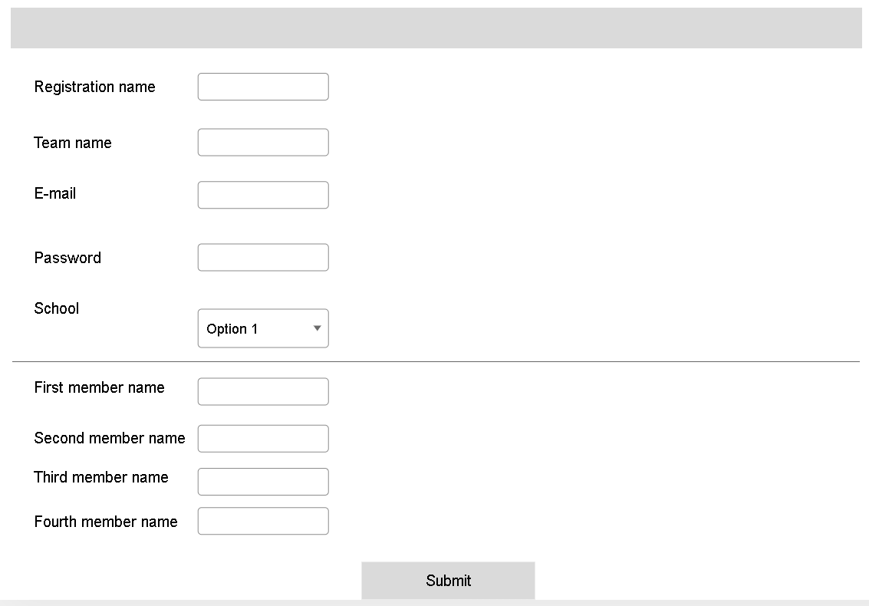

Log in page
The login page is accessible from the top navigation bar. By providing the registration username and its corresponding password, you can proceed to the game interface.

Game page
After the competition starts, participants can see the tasks. The tasks are displayed in a list, showing the task name, a brief description, and the score. The tasks are differentiated from each other. The tasks that the team has already solved are marked in green, the new unsolved tasks are in white, and the tasks without a solution but providing assistance to an existing task are in gray. Clicking on a task opens that specific task..
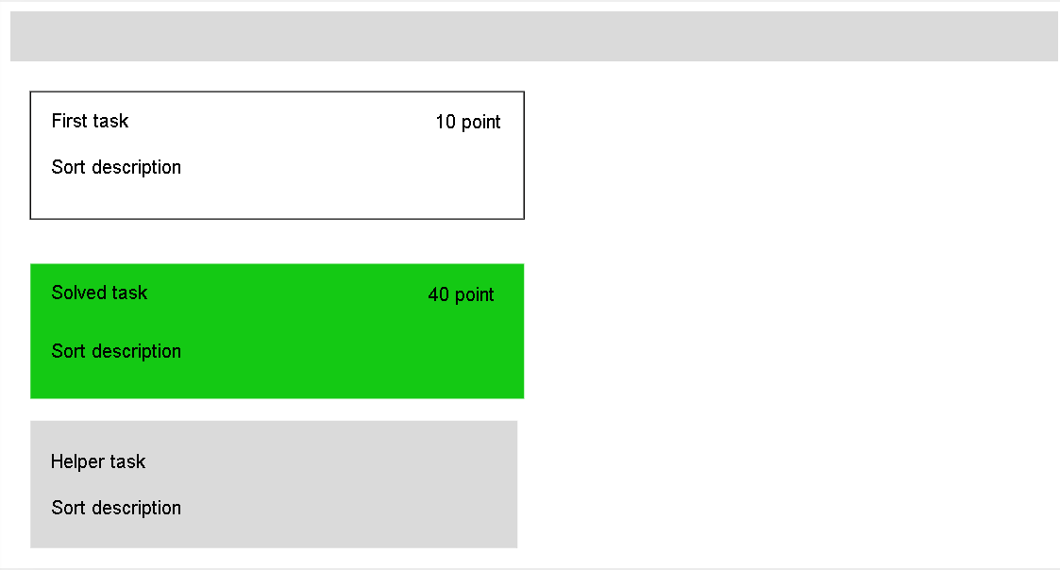

Task page
Here, the competing team can see the specific task, including its name, score, and the task itself. The task may include text, images, audio files, and video materials. The team can provide their guess or solution in the text field below.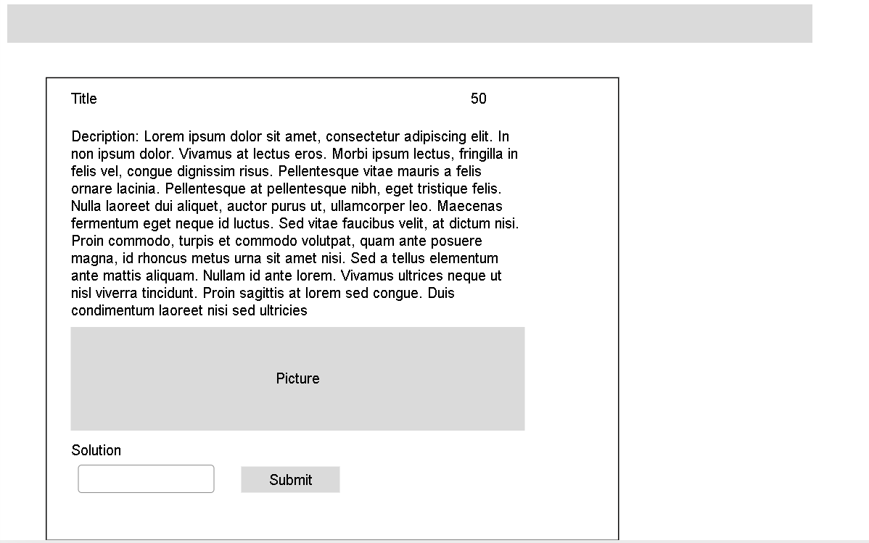

Result page
The result page contains a list of the current standings, showing how many points each team has accumulated and which tasks they have solved.

Admin page
The admin interface can only be accessed with appropriate permissions. Admins have the right to create, edit, and delete tasks. They can view the attempts of individual teams. They can create, start, pause, or delete competitions.

Edit Task
On the interface, admins can edit tasks. On this interface, they can provide the task name, score, and a brief description. They can set prerequisites, determining which task(s) need to be solved to make the current task accessible. They also need to specify which competition the task belongs to, using a dropdown menu. The task itself can be entered in a text box, including its content. The description can be expanded with various attachments, such as audio, images, or videos. Finally, the solutions can be provided. Some tasks may have multiple solutions, in which case it is sufficient for teams to come up with just one of them.
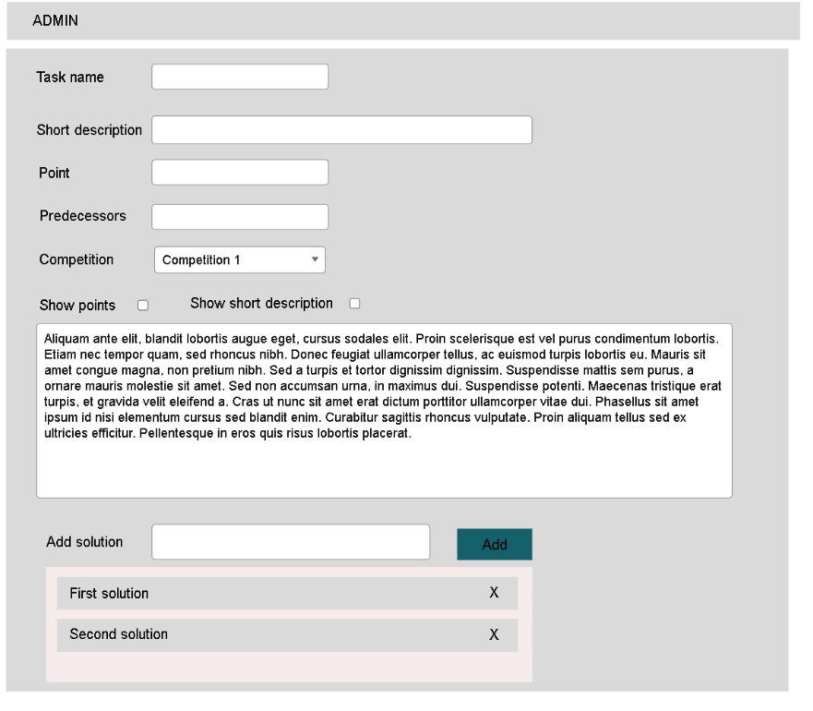

Submission
On this interface, you can view the submitted attempts. They are listed in a paginated table, showing which team attempted which task, when they attempted it, what solution they tried, and whether it was successful. For simplicity, there is also a filtering option where you can specify filtering conditions for certain columns.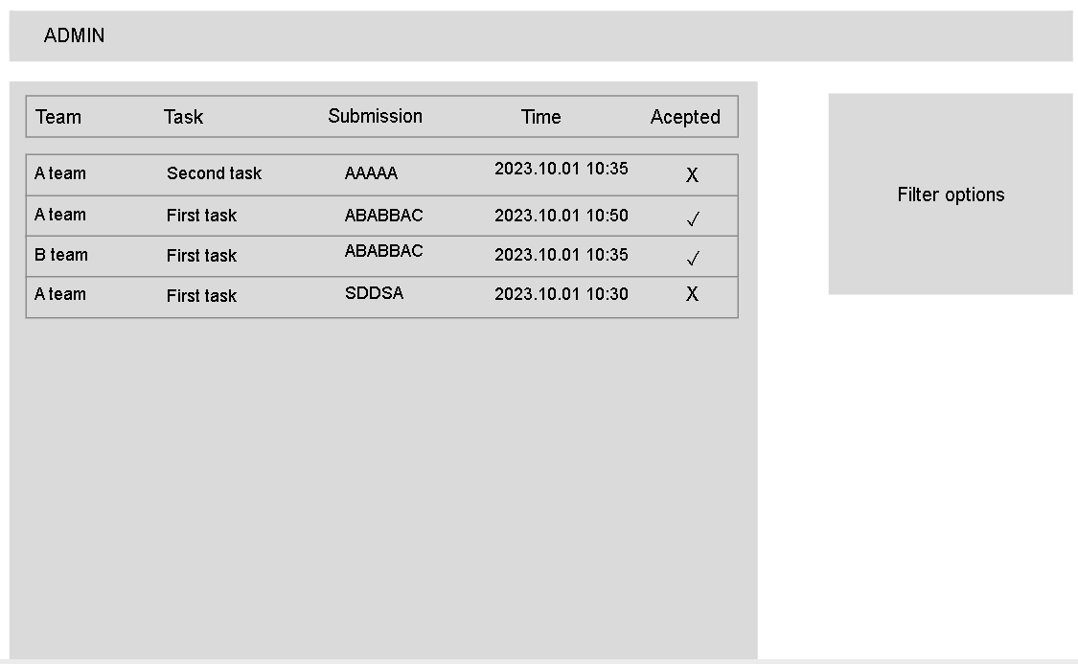

The Treasure Hunter game
Treasure Hunt is a game where teams have to navigate from a given text to reach the solution. The team that reaches the solution the fastest wins. The texts often contain hints or clues to open up the next set of tasks. These tasks can vary from logic puzzles to different types of riddles. They may include picture puzzles, codes hidden in audio files, texts embedded in videos, secret writings, encryption, and algorithms. During the competition, participants are allowed to use the internet or other resources for assistance, encouraging them to explore creative solutions. Some tasks may require participants to acquire specific knowledge before solving them.

Examples

Example
After this, unsurprisingly
,you keep decoding constantly.
In this, only three letters aid;
search instead, don't give up or fade.
LZW: 1,2,3,4,4,5,1,3,10,4 | A=1, B=2

Example
Unknown life form detected. Permission to proceed denied. Permission can only be granted after successful completion of the 'I am not a human' challenge. The robot displays a hologram. The animals depicted in the picture look quite peculiar, as if they were a blend of two real animals, one mammal and one bird.
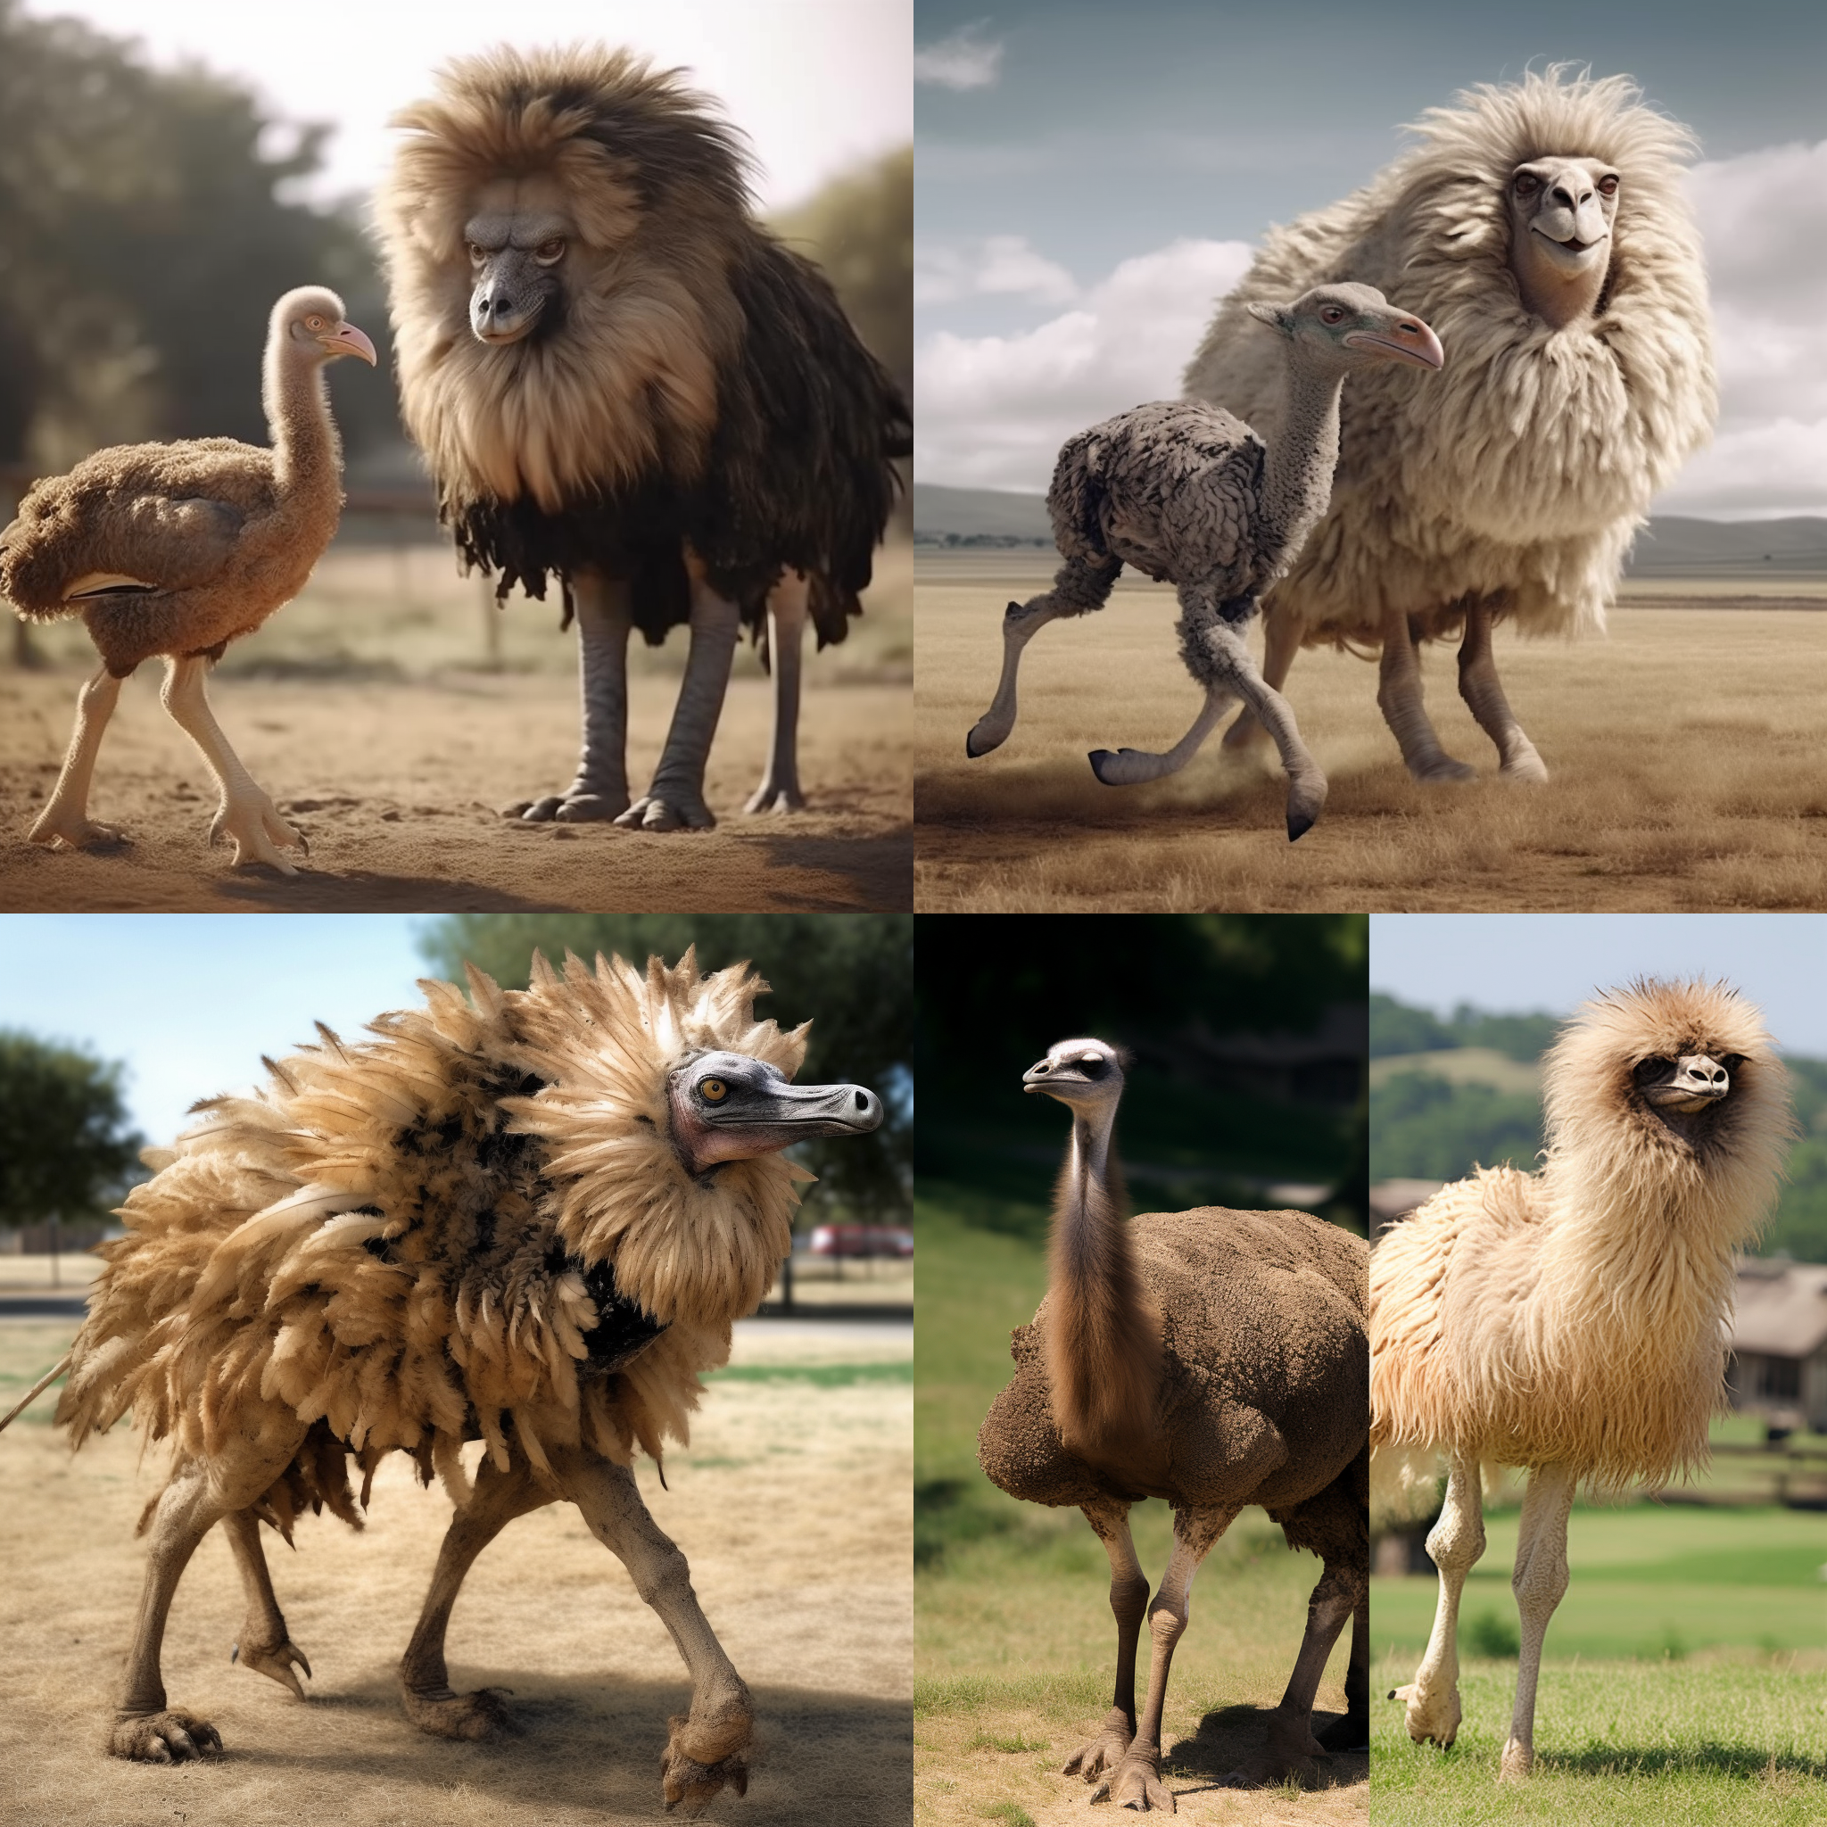

Example
Suddenly everything goes dark. When you regain consciousness, you find yourself in a military tent. You look around and see legionnaires surrounding you. Then you notice the envelope in your hand, which bears the inscription: Ex Caesare IX. What could the letter be about?
Vr jvrln erjcxa ljadb! Vrajarb oxabrcjw, bnm cn ngynlcjkjv. Wdwcrdb mn odcdarb vrqr mn jmenwcd cdx mrgrc. Qrl nwrpvj vrqr cajmrmrc, zdxm ldv "64 lxvydcjcarb" odcdarb lxwrdwlcdv nbbn mrgrc. Vducdv rwcnuungr wxw yxcdr, bnm crkr mrlnan yxbbdv, qdwl nwrpvjcj bxuenwmx lujenv yajncnarcr jmyaxyrwzdjcdadv nbbn. H2gqmvuiIGW0jF5cmGWyH2N=

Solutions

Example
LZW (Lempel-Ziv-Welch) is a compression algorithm, and the numbers should be decoded according to it.
Solution: ABABBABAABBAABABABA

Example
AI generated picture the sollution is: lionostrich

Example
Ex Caesare = From Caesar = Caesar encoding, IX = Shift of 9
From latin:
Dear traveler friend!
You might be surprised, but I've been expecting you. Someone from the future told me about your arrival. They handed me a puzzle, mentioning that it is related to some kind of "64 computer" in the future. I didn't understand much of it, but I can tell you that solving this puzzle will bring you closer to the key of the past.
64 computer = base64 coding
Y2xhdmlzZXN0aW5tdXNpY2E= solution: clavisestinmusica

Future plan
We intend to utilize the completed web application in various competitions. To achieve this, we will personally visit educational institutions to inform them about the possibility of organizing treasure hunt challenges. Our goal is to engage as many educational institutions as possible in these types of competitions, thereby promoting computer science, mathematics, and logical thinking among the younger generation. It is important for us to reach out to existing competitions and gain media coverage. Additionally, we aim to motivate teams to continue playing by offering valuable prizes. To accomplish this, we will approach companies to support the competitions. Acquiring further resources for prize provision is also crucial. Since the upcoming website allows us to organize competitions online, we can easily elevate a competition to an international level, as personal presence is not necessarily required during the competition. This means that the website and the competitions conducted on it will be accessible to students from other countries, providing them with a great experience while learning computer science and mathematics in a playful manner.

