Communication Event Interreg Europe
OD4GROWTH Project
August 29th, 2024
Strasbourg, France

Author | Grand E-Nov +, Benjamin Lallemand
Event / Meeting / Subject | Communication event – mid of the project (activity 1 semester 3) +  Stakeholders meeting n°3
Date, Location | Date: 29/08/2024.  Location: 2 Avenue de la fôret Noire, 𝗦𝘁𝗿𝗮𝘀𝗯𝗼𝘂𝗿𝗴  Oline event (physical and digital participation)  Region Grand Est, France  Summary: This unique opportunity to interact with key players in open data will help you find out how your territory could become a master in Open Data Management thanks to the OD4Growth learning action plan.  Inspirational example: An in-depth exploration of local data and its monumental impact on Attractivity.
Agenda | Programme:  2.00 pm - 2.10 pm: Introduction  - Welcome of participants  - Presentation of the issues of the meeting  2.10pm - 3.00pm: Mid-project update on the OD4Growth programme  - News on open data in France and Europe  - Sharing the results of past actions  - Presentation of future actions in the OD4Growth programme  - Discussions with participants to identify themes for future communication events and joint workshops  3.00 pm - 3.10 pm: Break  3.10pm - 3.40pm: Presentation by an expert  - Attractiveness and mapping of open data - What tools and opportunities for development?  3.40pm - 4.00pm: Stakeholders meeting no. 3  - Presentation of the results of the diagnosis of Open Data management capabilities (sharing of findings and needs)  - Introduction to some European best practices / Proposal for thematic working groups  - Presentation of the support actions planned to assist stakeholders in their Open Data approach  - Discovery of the self-training platform available to participants  16:00: Closing of the event
Participants | Stakeholders and other local public policy providers will be invited.  - ZENOU Barbara : barbara.zenou@strasbourg.eu  - C Benjamin  - CAVF- BUTTAZZI  - DE CADENET Pierre : p.decadenet@adeus.org  - DUYME Isabelle : isabelle.duyme@grandreims.fr  - MALLERET Fabien : fmalleret@bassinpompey.fr  - FASSEY Nicolas : nfassey@mairie-saintdizier.fr  - GUEDDOUM Noureddine : n.gueddoum@chalons-agglo.fr  - GUELLAFF kevin : kevin.guellaff@epinal.fr  - JACQUES Johann  - DECOLLOGNE Julien : jdecollogne@bassinpompey.fr  - MUCKENSTURM Pierre : pierre.muckensturm@grandreims.fr  - PEIFFERT Maxime : maxime.peiffert@agglo-thionville.fr  - TIERCELIN Steve : steve.tiercelin@agglo-valdefensch.fr  - THEVENIN Valérie : valerie.thevenin@troyes-cm.fr  - THOMAS Rémi : remi.thomas@epinal.fr  - Troyes Champagne Métropole  - LALLEMAND Benjamin : b.lallemand@grandenov.plus  - SOVIGNET Audrey : a.sovignet@grandenov.plus  - RAKOTOVAO Prosper : prosper.rakotovao@agglo-epinal.fr
Links to further Information
Summary of the meeting

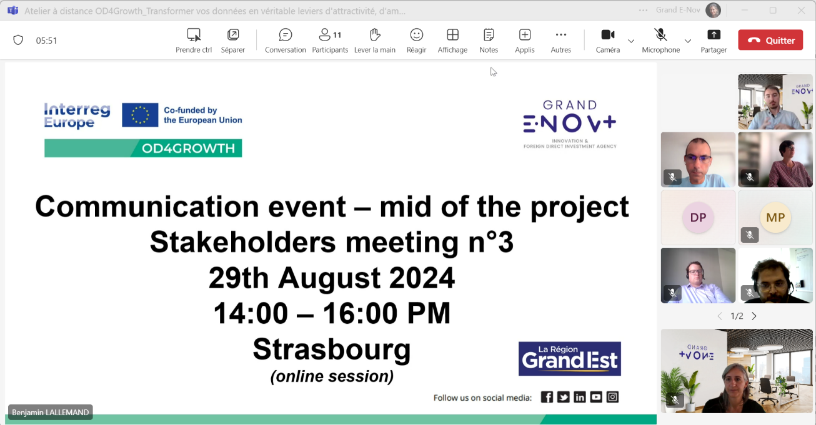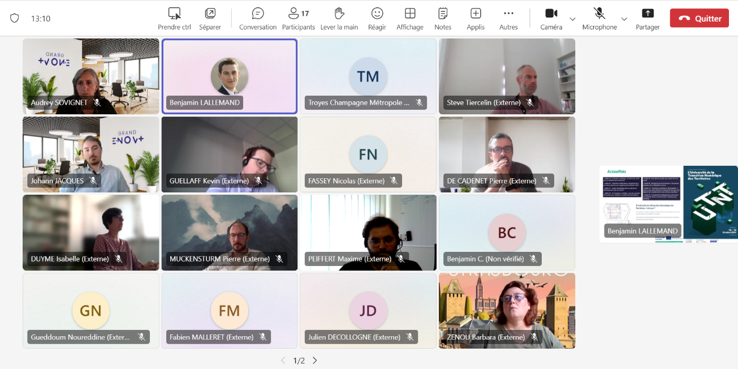
This meeting provided our 18 participants, representing municipalities, cities, and departments, with the opportunity to realize that they share common challenges related to data management. The exchange of best practices among them proved to be relevant and generated significant interest.
Furthermore, this event facilitated an initial contact with Johann Jacques, Project Manager of "Foncier Nouvelle Génération" at Grand E-Nov +, and allowed participants to discover the national initiative for creating a land use database. This encounter promises to enhance the perspectives for managing and optimizing territorial data for all participants.

Follow-up meeting | Individual follow-up upon request + Stakeholders n°4
Resources
Other personal remarks

