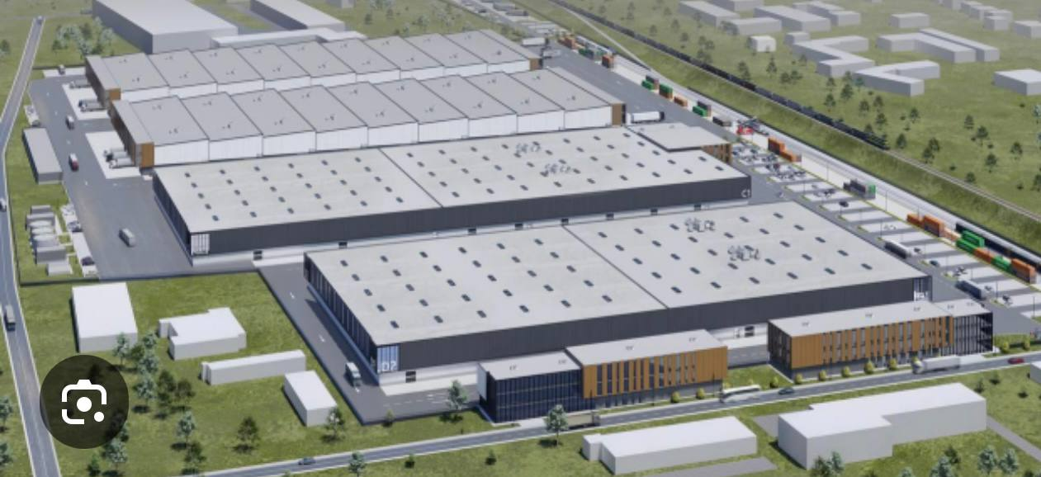

**Construction of the "Glass City" Industrial Park**

**Introduction**  
The goal of the project is to construct a compact eco-industrial park, "Glass City," specializing in the production of glass and glass products. The project aims to use advanced energy-efficient technologies and principles of industrial symbiosis to reduce environmental impact and enhance economic efficiency.

**2. Location and Infrastructure**  
**Location**: An industrial zone located away from residential areas but with access to highways and railroads.  
**Land area**: 5-10 hectares, which will accommodate the main production facilities, warehouses, and infrastructure to support the park's businesses.

**3. Technical Specifications**  
**Glass production capacity**:

* Production of construction, automotive, and technical glass.
* Capacity: 50-100 thousand tons of glass per year.

**Energy efficiency**:

* **Solar panels**: Renewable energy use to cover up to 20% of energy needs.
* **Waste heat recovery**: Reusing heat from the glass melting process.
* **Cogeneration**: A system for simultaneous heat and electricity production using natural gas.

**Environmental solutions**:

* **Glass recycling**: Recycling broken glass and waste to reduce material waste and raw material costs.
* **Emission filtration**: Modern filters to minimize CO₂ emissions.
* **Water recirculation systems**: A closed-loop system to reduce water usage.

**4. Industrial Symbiosis**  
**Shared resource use**:

* Other companies can use glass production residues for their processes, such as in construction or material manufacturing.

**Collaboration between companies**:

* Exchange of waste and resources, such as heat and energy, to reduce production costs and decrease environmental impact.

**5. Project Budget**  
**Construction of production workshops**:

* Land acquisition and preparatory work: 2 million EUR
* Construction of glass production workshops: 25 million EUR
* Purchase of equipment for glass melting and processing: 40 million EUR

**Energy-efficient systems**:

* Installation of solar panels: 4 million EUR
* Cogeneration systems: 6 million EUR
* Water recirculation systems: 3 million EUR

**Infrastructure**:

* Logistics and warehouse facilities: 5 million EUR
* Offices and automated control systems: 3 million EUR

**Total project cost**: 88 million EUR

**6. Economic Efficiency and Payback**  
**Profitability**:

* Expected profitability is 18-22%, due to reduced energy costs and material recycling.

**Payback period**:

* The project's payback period is forecasted at 7-9 years, considering the high demand for glass products and efficient resource utilization.

**Annual income**:

* Projected income is 50-70 million EUR per year, depending on market conditions.

**7. Glass Market Analysis for 10 Years**  
**Demand growth**:

* Annual demand for glass is expected to grow by 5-7%, driven by the increased need for construction and energy-efficient glass.

**Global trends**:

* Increased demand for energy-efficient glass and materials for solar panels will contribute to the steady growth of the market.

**8. Conclusion**  
The eco-industrial park "Glass City," covering 5-10 hectares, is an innovative project that combines energy-efficient solutions, environmental approaches, and industrial symbiosis. High profitability and a quick payback period make this project attractive for investment in the glass industry.

