Interreg Europe 8th Monitoring Committee meeting
2021-2027

3 and 4 June 2025,
Gdańsk (Poland)
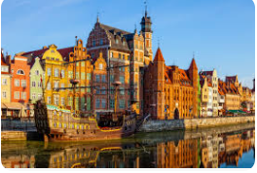

VENUE
Scandic Gdansk
Podwale Grodzkie 9
80-895 Gdansk
Scandic Gdansk | Hotel in Gdansk | Scandic Hotels
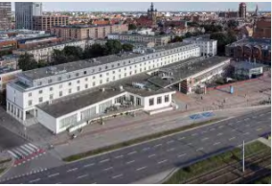

REGISTRATION
You are kindly asked to register by Friday 16 May 2025, at the latest via our website

You’ll first have to login to your using the same email & password as the Portal in order to access the registration form.

In case of problem, send a screenshot of the error message to Julie (j.patenaude@interregeurope.eu) and Laure (l.lesec@interregeurope.eu)

SOCIAL ACTIVITY & DINNER ON TUESDAY 03 JUNE

A social activity as well as an official dinner, offered by the Polish presidency of the Council of the EU, will be held on Tuesday 03 June. Additional information will be provided at a later stage.

GET TO THE VENUE

From the airport
Bus 210 is direct from the airport to the city center. It runs every 30 minutes and the approximate travel time is 45 minutes. 23 stops until “Dworzec Główny 05” bus stop (2 mn walk from the venue)
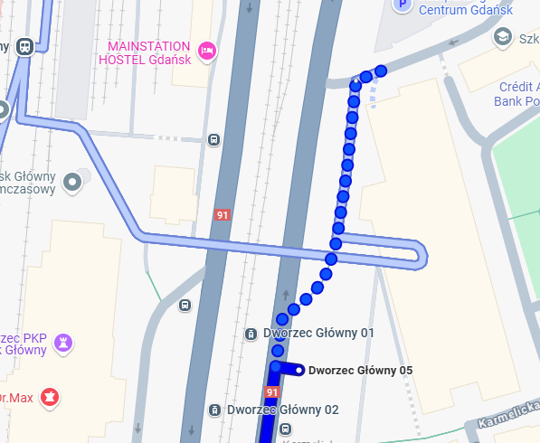
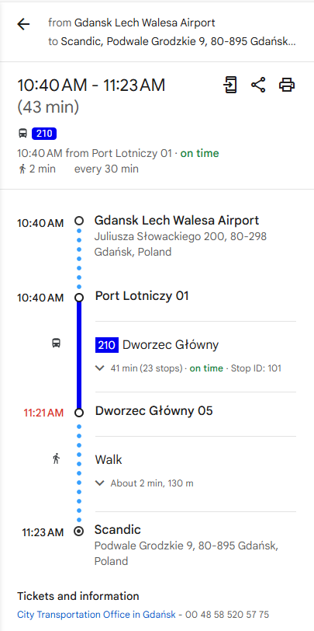

HOTEL RESERVATION

We kindly ask you to make your own arrangements for accommodation as soon as possible.
There are several hotels close to the venue.
Scandic hotel (venue)
15% discount using this link: Scandic Gdansk | Hotel in Gdansk | Scandic Hotels
(you just need to indicate the number of people and the desired date of stay, the discount code is already entered)

Central Hotel Gdańsk
Hotel Central

Hotel Mercure Gdańsk Stare Miasto
Rates - Mercure Gdansk Stare Miasto ALL - Accor Live Limitless

Hotel ibis Gdansk Stare Miasto
Rates - ibis Gdansk Stare Miasto ALL - Accor Live Limitless

PRACTICAL INFORMATION

Emergency number: 112
Time zone: European Time Zone (GMT +1)
Dialing code: +48
Local currency: PLN (Polish złoty)
1 EUR = PLN 4,1839
Power supply: the electric supply is 230V with 50Hz frequency

ADDITIONAL INFORMATION

Famous places in the vicinity of Gdansk:
- Nicolaus Copernicus: city of Toruń – on the UNESCO list https://whc.unesco.org/en/list/835/
- Teuton castle: on the UNESCO list, in the city of Malbork) https://whc.unesco.org/en/list/847/

