Good Practice template

- In order to submit a practice, you will have to register in the Interreg Europe website. You can submit your practice through your user dashboard (‘Good practices’ tab).
- Optional fields are shown in orange. All other fields are compulsory.

- Author contact information

[Technical: Contact information comes from your community profile. You can edit it by visiting your user dashboard]
The owner of the good practice should fill in the form. If you submit a good practice, your personal and organisational profile in the Interreg Europe community will be linked to it.
Name: | Anthoula Nikopoulou
Email: | a.nikopoulou@pkm.gov.gr
Telephone: | +302313319791
Your organisation
Country: | Greece
Region: | Central Macedonia
City: | Thessaloniki
Organisation name: | Region of Central Macedonia (RCM)

- Organisation in charge of the good practice
[If your organisation is not the one in charge of the good practice, you can indicate the relevant organisation in this section of the form. But your contact details will still be linked to the submitted good practice. ]

Is your organisation the main institution in charge of this good practice? | No

In case ‘no’ is selected, the two following sections appear:

Location of the organisation in charge: | Country | Greece
 | Region | Central Macedonia
 | City | Thessaloniki
Main institution in charge: | Anatolia College

Are you involved in an Interreg Europe project? | Yes
If you are involved in more than one project, please choose the project for which you are submitting this good practice.
See our list of approved projects or visit this FAQ section for more information.

In case ‘yes’ is selected, the following section appears:

Please select the project acronym: | MINEV

- Good practice general information
If you are submitting a good practice as part of an Interreg Europe project, the thematic objective and sub-topic are chosen for you.

If you are not part of an Interreg Europe project, please remember to choose the most relevant thematic objective and sub-topic for your good practice.
Thematic objective of the practice: | In case the good practice is not part of an Interreg Europe project, selection of one of the 6 specific objectives
Thematic subtopics of the practice: | In case the good practice is not part of an Interreg Europe project, selection of one of the 17 subtopics
Geographical scope of the practice: | Regional
Location of the practice | Country | Greece
 | Region | Central Macedonia
 | City | Thessaloniki

Practice image: | 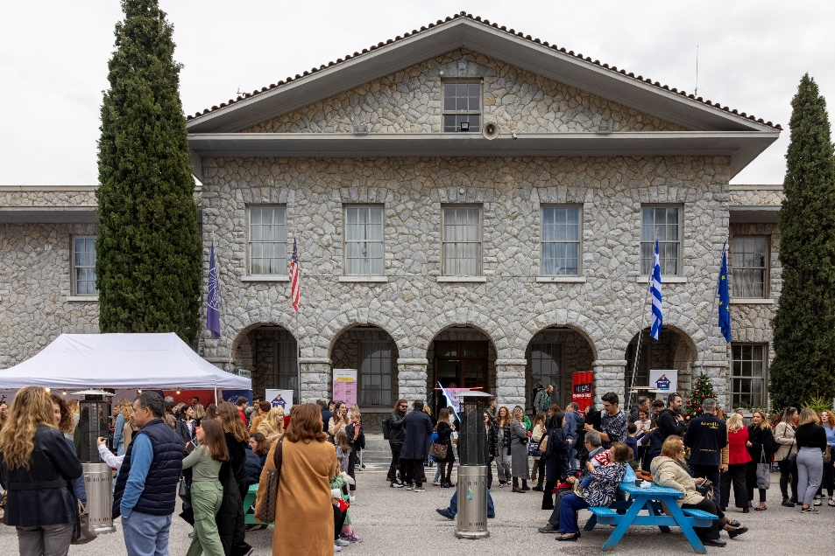  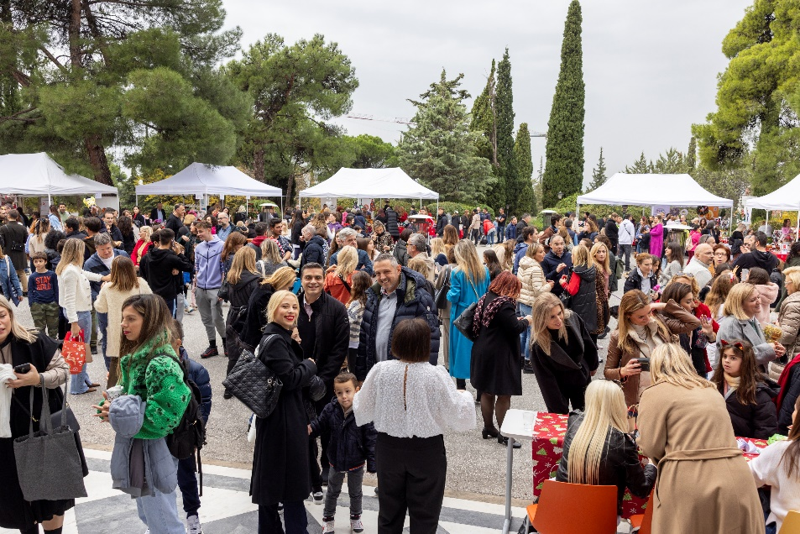
Title of practice: | Waste Management in Anatolia College events

- Good practice detailed information
Short summary of the practice: | Comprehensive Waste Management Strategy for Large-Scale Events in Anatolia College
Detailed information on the practice: | Large-scale events often generate significant amounts of waste, contributing to environmental degradation and resource depletion. Without proper management, this waste can end up in landfills, harming ecosystems and human health.  Anatolia College has developed a comprehensive waste management strategy to minimize waste generation and promote recycling and reuse during its events. This includes collaboration with various organizations for waste collection, redistribution of surplus food and recycling of paper and plastic. Additionally, Anatolia College has implemented measures to reduce its environmental footprint, such as transitioning to renewable energy sources and banning plastic bottle sales on campus.  The objective is to significantly reduce waste generation and increase recycling rates during large events, ultimately aiming for zero waste.  Targets include diverting a certain percentage of waste from landfills, increasing awareness among students, faculty and staff about waste reduction practices, and fostering a culture of sustainability within Anatolia College community.  The expectation is to create a model for sustainable event management that can be replicated by other institutions.
Resources needed: | Departments of Anatolia (facilities management, event planning, & sustainability initiatives) collaborate to implement waste management strategy. Staff members oversee waste collection, recycling, & awareness campaigns. Financial resources are allocated for waste collection and educational programs.
Timescale (start/end date): | The waste management strategy has been implemented gradually over the years, with ongoing efforts to improve and expand its scope.
Evidence of success (results achieved): | Anatolia collaborates with external organizations for waste management, like ANAKEM for construction waste collection, BOROUME for surplus food redistribution, ELDIA for recycling. Social welfare organizations like DESMOS facilitate the donation of technology equipment. Anatolia has reduced its environmental impact at large events. By banning the sale of plastic bottles and installing water coolers, 18,000 plastic bottles are saved per month. Since 2022, 600,000 plastic bottles have been saved.
Challenges encountered (optional): | Challenges such as waste sorting and contamination remain. Behavioral change of students, faculty, parents and alumni are difficult to be achieved, requiring ongoing education. Also, logistical challenges arise in coordinating waste management activities across departments and partners.
Potential for learning or transfer: | The initiative of Anatolia college can easily be transferred to other regions. The important part is to find the proper collaborations with external organizations for waste management specialized in construction waste collection, surplus food distribution and paper/ plastic recycling.
Further information: | Link to where further information on the good practice can be found
Keywords related to your practice | Select from existing keywords
Expert opinion | [1500 characters] [Filled in by the Policy Learning Platforms experts in case good practice is published in the Good Practices database]

*Please attach 3 pictures that describe your practice. Do not insert them into this document but send them as separate files, please.

- Additional info (only for MINEV project purposes)

This is simply to have some additional information and material for compiling the collection of good practices.
Testimonial: | At the beginning of our initiative to ban the sale of plastic bottles on campus, we faced resistance from some students who were reluctant to change their habits. However, after three years of dedication and perseverance, it's incredibly rewarding to see how proud they've become of our collective efforts. Witnessing the transformation in their attitudes towards sustainability has been truly inspiring, and it reaffirms the impact we can achieve when we work together towards a common goal.
Person who gave the testimony: | Mrs Peggy Perakaki  Coordinator of Social Responsibility Programs  Anatolia College

