Good Practice template

- In order to submit a practice, you will have to register in the Interreg Europe website. You can submit your practice through your user dashboard (‘Good practices’ tab).
- Optional fields are shown in orange. All other fields are compulsory.

- Author contact information

[Technical: Contact information comes from your community profile. You can edit it by visiting your user dashboard]
The owner of the good practice should fill in the form. If you submit a good practice, your personal and organisational profile in the Interreg Europe community will be linked to it.
Name: | Anthoula Nikopoulou
Email: | a.nikopoulou@pkm.gov.gr
Telephone: | +302313319791
Your organisation
Country: | Greece
Region: | Central Macedonia
City: | Thessaloniki
Organisation name: | Region of Central Macedonia (RCM)

- Organisation in charge of the good practice
[If your organisation is not the one in charge of the good practice, you can indicate the relevant organisation in this section of the form. But your contact details will still be linked to the submitted good practice. ]

Is your organisation the main institution in charge of this good practice? | No

In case ‘no’ is selected, the two following sections appear:

Location of the organisation in charge: | Country | Greece
 | Region | Central Macedonia
 | City | Thessaloniki
Main institution in charge: | Thessaloniki Film Festival (TFF)

Are you involved in an Interreg Europe project? | Yes
If you are involved in more than one project, please choose the project for which you are submitting this good practice.
See our list of approved projects or visit this FAQ section for more information.

In case ‘yes’ is selected, the following section appears:

Please select the project acronym: | MINEV

- Good practice general information
If you are submitting a good practice as part of an Interreg Europe project, the thematic objective and sub-topic are chosen for you.

If you are not part of an Interreg Europe project, please remember to choose the most relevant thematic objective and sub-topic for your good practice.
Thematic objective of the practice: | In case the good practice is not part of an Interreg Europe project, selection of one of the 6 specific objectives
Thematic subtopics of the practice: | In case the good practice is not part of an Interreg Europe project, selection of one of the 17 subtopics
Geographical scope of the practice: | Regional
Location of the practice | Country | Greece
 | Region | Central Macedonia
 | City | Thessaloniki

Practice image: | Upload your own (in compliance with the copyright rules) or select one from the pool of pre-defined images. Recommended dimensions: 440 x 450 pixels, 1MB  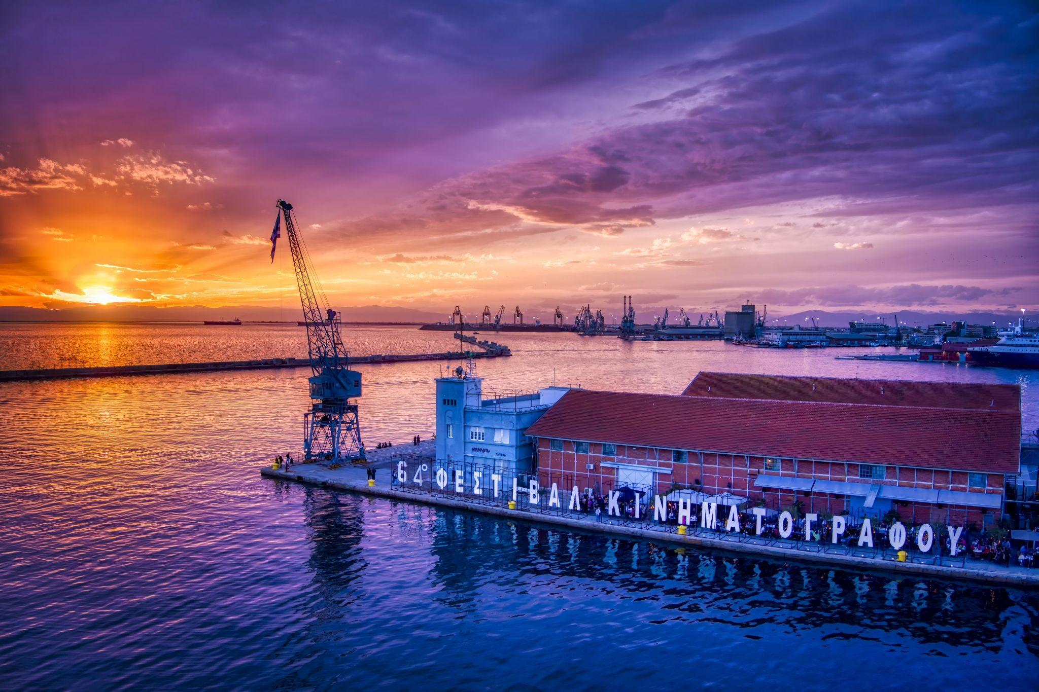  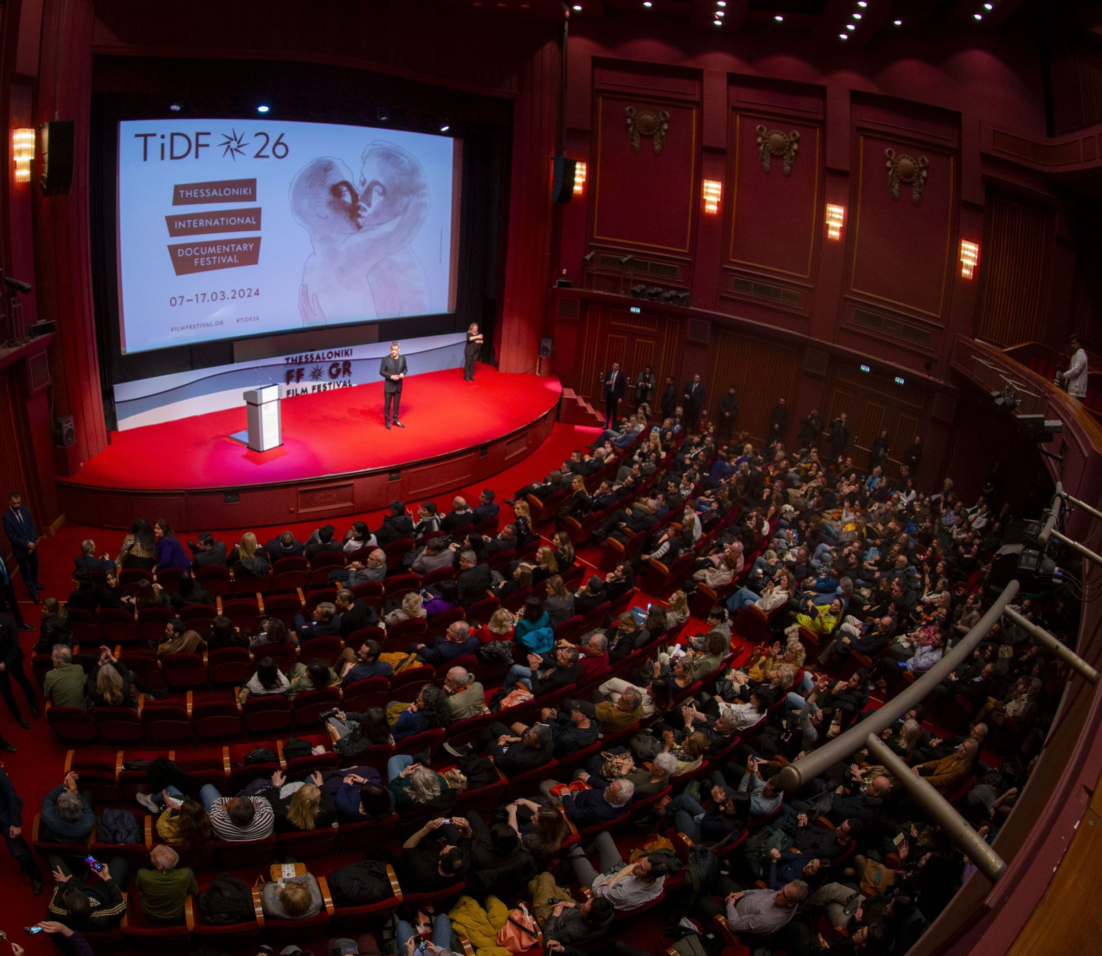  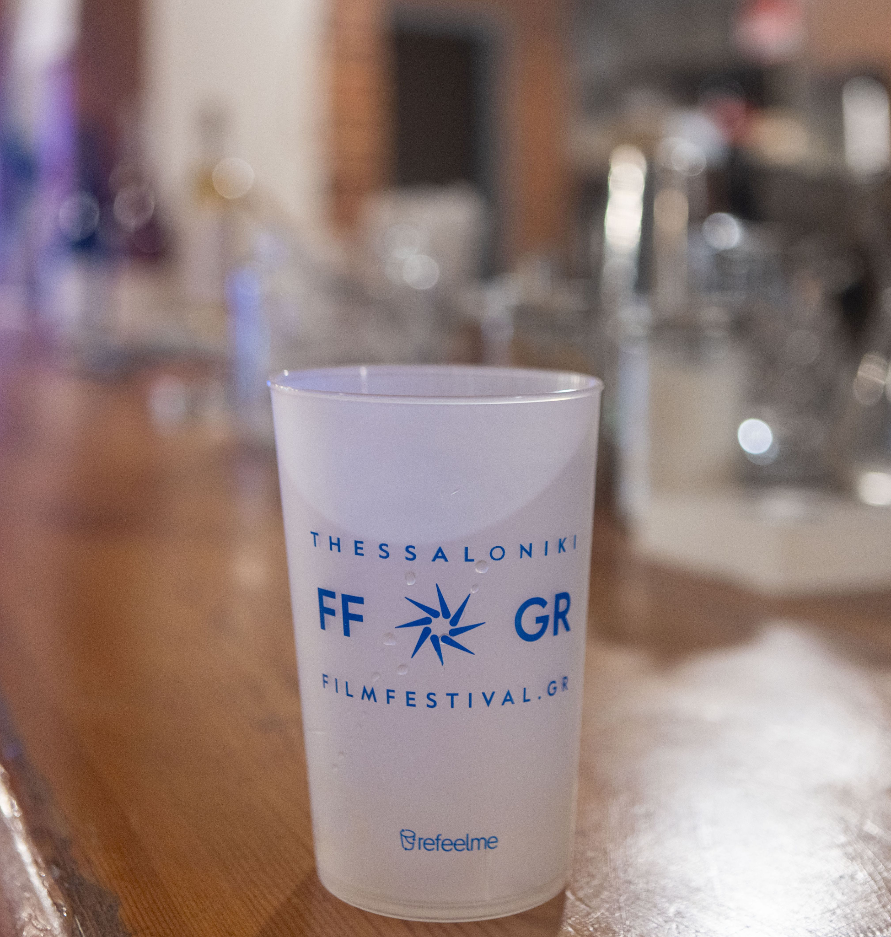  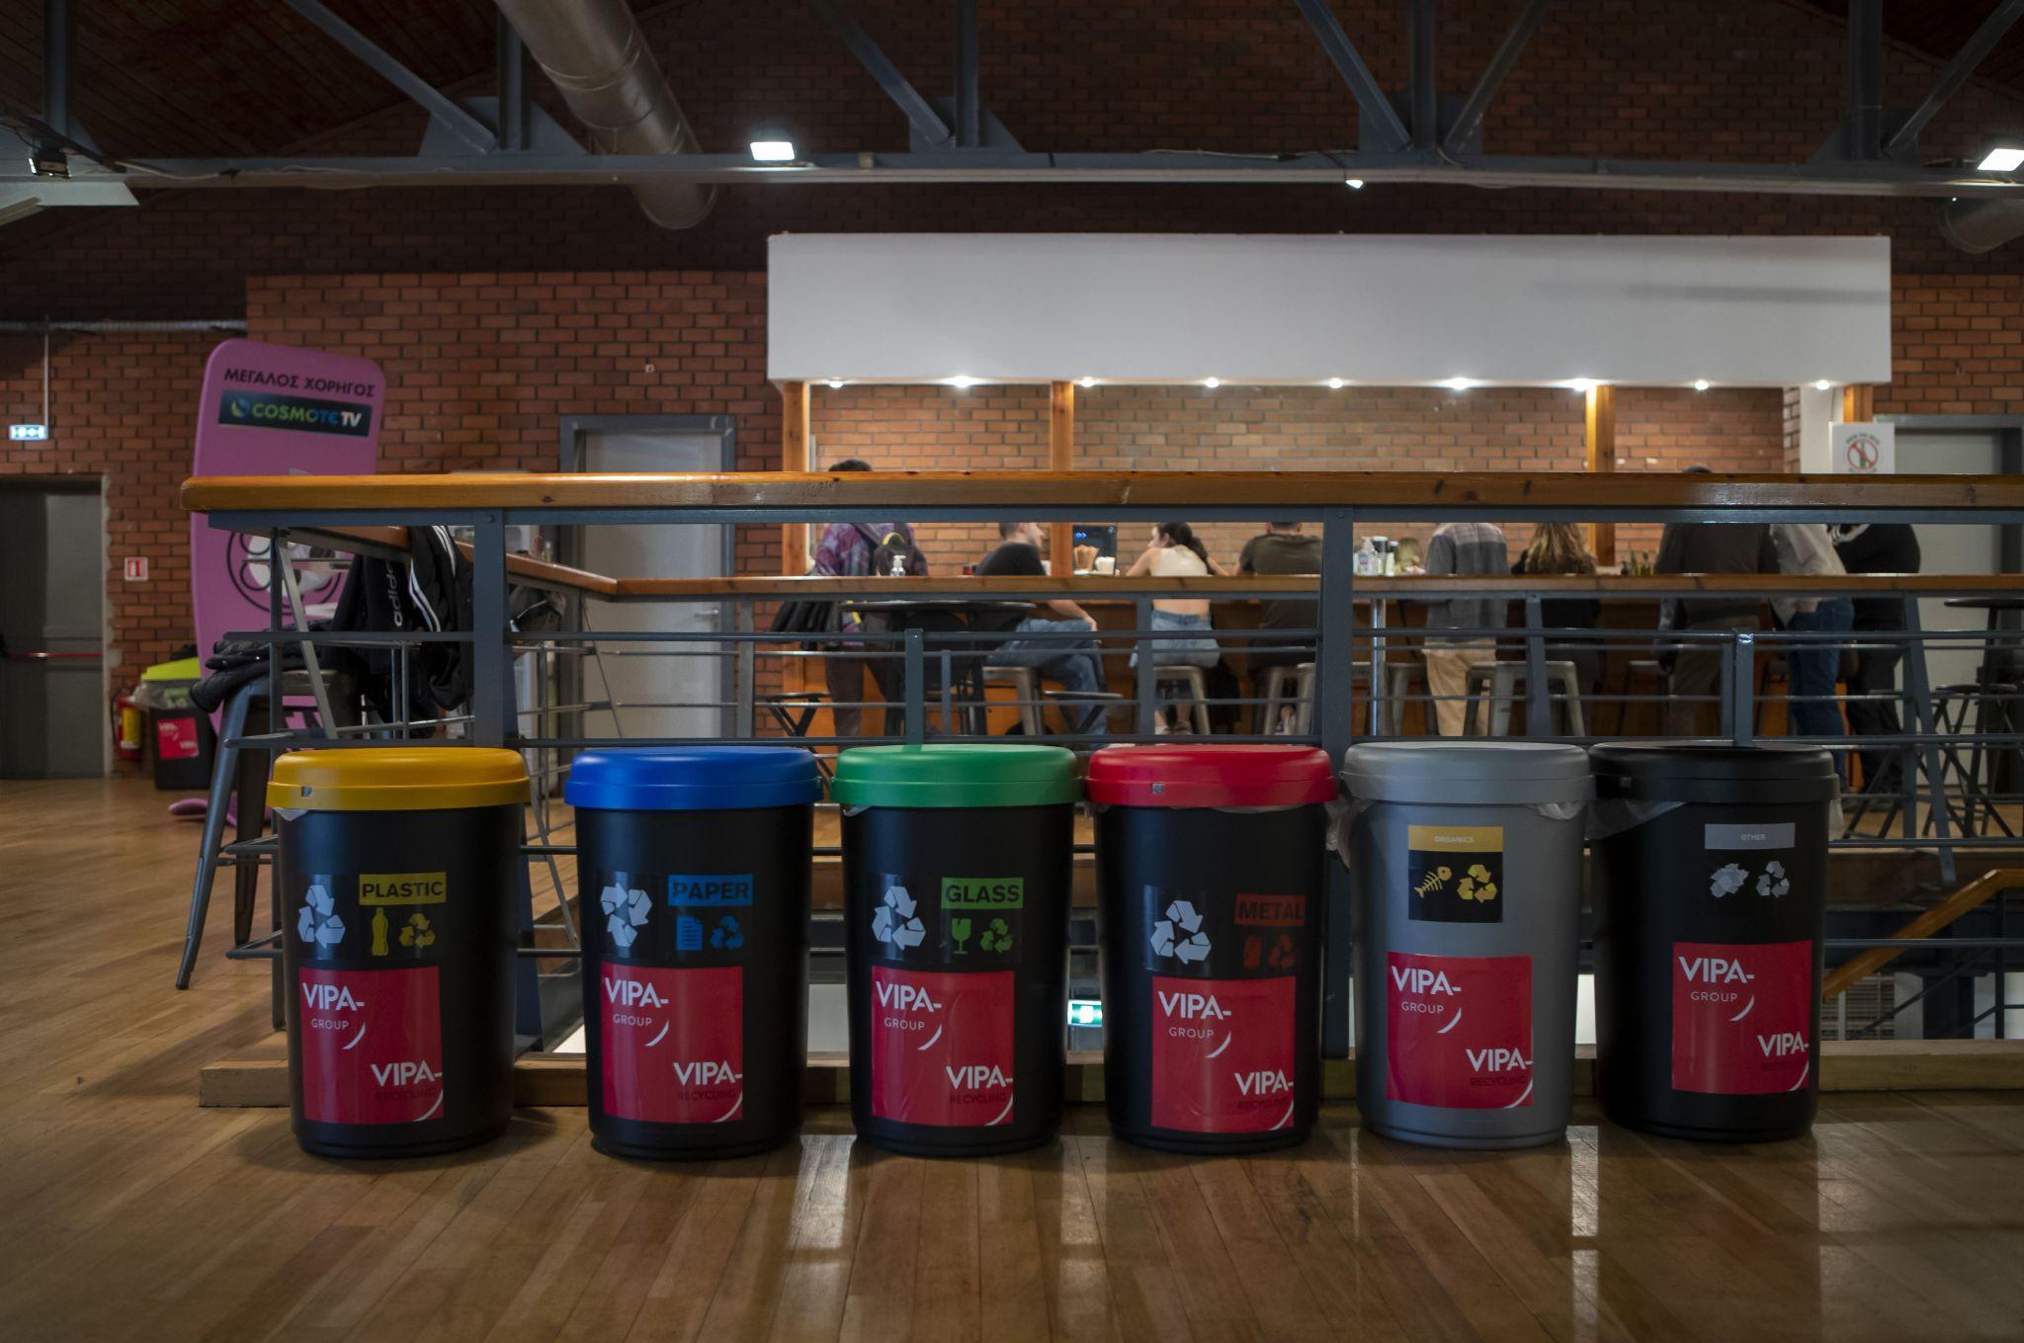  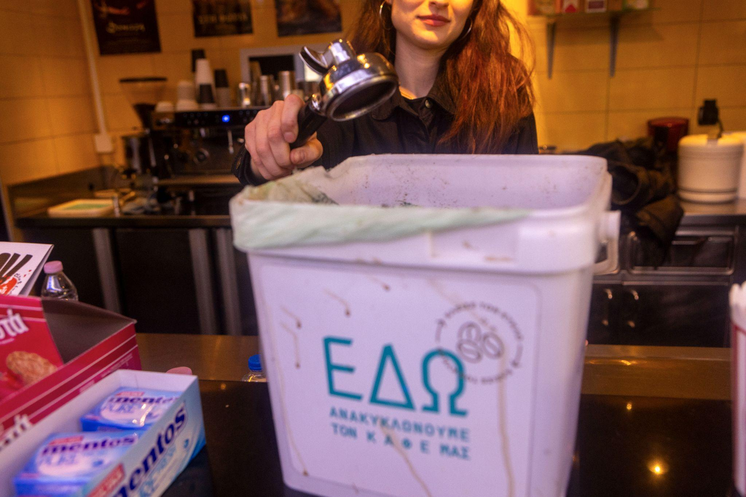  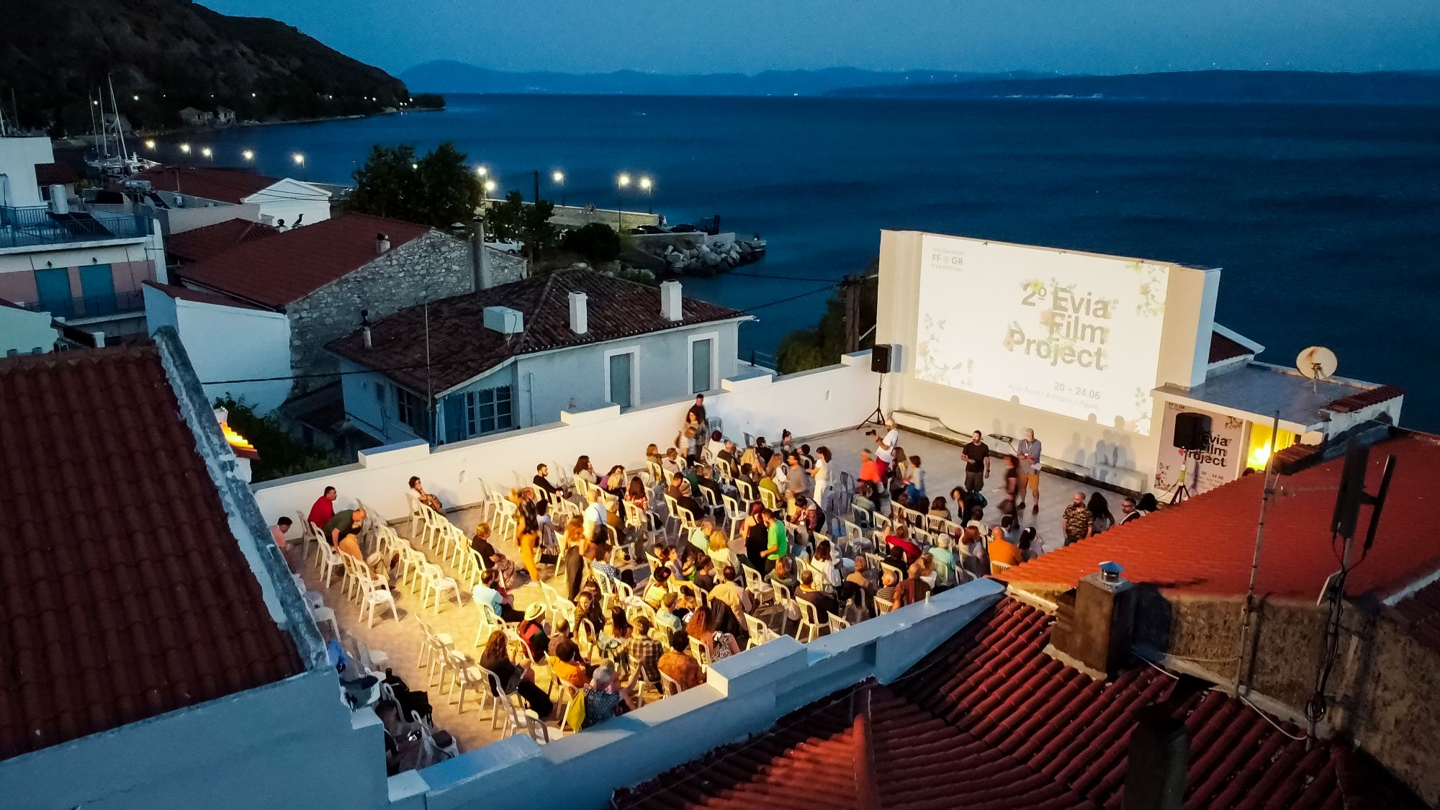
Title of practice: | Making a Film Festival Greener

- Good practice detailed information
Short summary of the practice: | Comprehensive Waste Management Strategy in Film Festivals:  TFF’s commitment to constitute an action plan to join global efforts towards a sustainable future:  Thessaloniki Film Festival (TFF) is the largest film institution in Greece, which offers quality cinema and cinematic events all year round and attracts thousands of people in its events.  TFF’s environmental policy, overseen by the General Director, is being detailed and systematized into an action plan, meant to constitute an integral part of its administration, daily operations and overall organizational culture. The action plan will be regularly revised and re-evaluated and will continue to reflect and support TFF’s environmental ambition over the coming years.  The policy constitutes TFF’s commitment to join global efforts towards a sustainable future, support the goals of the Paris Agreement and of the EU Green Deal, contribute to Thessaloniki’s role in the “EU mission: 100 Climate Neutral and Smart Cities”, and comply with Greek environmental legislation and the country’s climate targets.
Detailed information on the practice: | [1500 characters] Please provide information on the practice itself. In particular:  - What is the problem addressed and the context which triggered the introduction of the practice?  - How does the practice reach its objectives and how it is implemented?  - Who are the main stakeholders and beneficiaries of the practice?  Policy formulation for all TFF’s activities requires specialized consulting services. Thus, in March 2023, the Festival assigned to an expert consultant on sustainable cultural management the task of designing the Organization's environmental policy, strategy and action plan and their effective implementation.  TFF has commissioned a carbon footprint analysis and energy audit of its venues and operations.  TFF is a co-signatory of the Green Charter for Film Festivals, a European initiative of the Festival Network MIOB. By registering, festivals commit to “follow a progression path to lower the pollution generated by our activities and be in a constructive attitude towards our environment”.  A Green Team was formed, with the participation of staff members from across the organization. Three introductory training seminars have been held for all employees and partners, as well as for festival volunteers.  A series of individual advisory-educational workshops (thematic seminars) are currently taking place, on the following subjects: policy-strategy, legal & ethical issues in regards to environmental sustainability and sustainable management, energy & water management, materials & waste management, procurement, digital footprint & digital sobriety, travel & offsetting, communication & outreach).
Resources needed: | [300 characters] Please specify the amount of funding/financial resources used and/or the human resources required to set up and to run the practice.  The Festival tries to utilize European financial tools. The energy upgrade of Olympion is co-funded by the Region of Central Macedonia and the European Regional Development Fund. The Festival wishes to finance further energy upgrading interventions for the OLYMPION, Warehouse C and Cinema Museum.
Timescale (start/end date): | Autumn 2022 – ongoing  TFF’s environmental policy is being detailed and systematized into an action plan and aims at a horizontal application of sustainable thinking and practice in all decision-making processes of the Festival, initially in the course of the next three years. The goal, environmentally-wise, is always setting higher standards.
Evidence of success (results achieved): | [500 characters] Why is this practice considered as good? Please provide factual evidence that demonstrates its success or failure (e.g. measurable outputs/results).  TFF collaborates with VIPA GREECE S.A., InCommon,and Cigaret Cycle. VIPA showed that water coolers reduced the single-use plastics. InCommon reported that training partners, guests and audience contributes to sorting at source. Cigaret Cycle's reported in 2022, 70.800 cigarette butts collected, while in 2023 102.500 cigarette butts were recycled, 718 m3 of sweet/salted water was saved from pollution, 656 kg of CO2 was not released in the environment, 15.980 MJ of non-renewable energy was saved.
Challenges encountered (optional): | [300 characters] Please specify any challenges encountered/lessons learned during the implementation of the practice.  Resources for green strategies & energy upgrading. For a green travel policy, with the limited opportunities for sustainable travel, it is challenging to cope with the social dimension of festival events, based on the principle of European cultural programs for fair, greener and inclusive mobility.
Potential for learning or transfer: | [1000 characters] Please explain why you consider this practice (or some aspects of this practice) as being potentially interesting for other regions to learn from. This can be done e.g. through information on key success factors for a transfer or on, factors that can hamper a transfer. Information on transfer(s) that already took place can also be provided (if possible, specify the country, the region – NUTS 2 – and organisation to which the practice was transferred)  [Technical: A good practice be edited throughout a project life time (e.g. to add information on the transfers that have occurred)]  TFF communicates its environmental policy to public and private bodies to encourage them adopt similar practices & become active partners for green and sustainable future. Access to training material, good practice guides, case studies from the cultural sector internationally is provided to Festival’s team. Regular updates for climate issues and innovations in sustainability are shared among staff members. Emphasis is placed on training and compliance with the general framework of the Green Deal and individual policies, e.g. EU: Green Procurement, Greening Creative Europe, and on carbon offsetting frameworks and best practices to avoid greenwashing. TFF’s environmental policy revises internal procedures, updates work protocols and re-evaluates priorities. In order to achieve this change of mentality, TFF cultivates and develops green skills among staff and collaborators, embeds sustainable clauses in the job descriptions and roles of employees & in the contracts of external partners.
Further information: | Link to where further information on the good practice can be found  Additional information is available to guests through TFF’s website and the ThessFest App  https://www.filmfestival.gr/en/festivals-en/environmental-sustainability  The Green team can be reached via greenteam@filmfestival.gr  As a co-signatory of the Green Charter for Film Festivlas, TFF has already submitted all the data for the 63rd and 64th Thessaloniki International Film Festivals (November 2022 and 2023 respectively), as well as the data for the 25th Thessaloniki International Documentary Festival/March 2023, while the relevant information from the recent 26th Documentary Festival/March 2024 are currently being collected.  (https://greencharterforfilmfestivals.org/up/CharterGCFFF.pdf)
Keywords related to your practice | Select from existing keywords  responsibility  environmental policy  action plan  commitment  sustainable future  carbon footprint analysis  energy audit  waste management  procurement of services/food/materials  Green Team  training procedures
Expert opinion | [1500 characters] [Filled in by the Policy Learning Platforms experts in case good practice is published in the Good Practices database]

*Please attach 3 pictures that describe your practice. Do not insert them into this document but send them as separate files, please.

- Additional info (only for MINEV project purposes)

This is simply to have some additional information and material for compiling the collection of good practices.
Testimonial: | Please ask someone who directly worked on the initiative (development or implementation) on your organisation’s behalf to tell you his/her impressions or story. Up to 3-5 sentences. We would use it as a quotation in the publication.  Cultural organizations like the Thessaloniki Film Festival, operate in a familiar cultural, economic and social economic ecosystem. We know our impact on our industry and our communities. But we have for too long ignored our environmental ecosystem and the impact of our activities on the environment. This is why, for several years now, we have focused our efforts on environmental issues. The work is complicated, new, time consuming and it requires the collaboration of everyone in the team for a cause that is often invisible. Mobilizing a team around this project was the first achievement. I am very proud of the journey and the progress we have done so far, thanks to the dedication and energy or our Green Officer who initiated and coordinated every step. We have a long way to go, but we are very optimistic because we believe that our efforts are more than worth it and the environmental cause is an absolute priority.
Person who gave the testimony: | Elise Jalladeau, General Director of the Thessaloniki Film Festival

