Good Practice

Waste prevention at the Franciscan Festival

- Author contact information
Name: | Giulia Maselli
Email: | Giulia.maselli@cittametropolitana.bo.it
Telephone: | +39 3791823723
Your organisation
Country: | Italy
Region: | Emilia-Romagna
City: | Bolonia
Organisation name: | Metropolitan City of Bologna

- Organisation in charge of the good practice
Is your organisation the main institution in charge of this good practice? | No

In case ‘no’ is selected, the two following sections appear:

Location of the organisation in charge: | Country | Italy
 | Region | Emilia-Romagna
 | City | Bolonia
Main institution in charge: | Franciscan Movement of Emilia-Romagna

Are you involved in an Interreg Europe project? | Yes

In case ‘yes’ is selected, the following section appears:

Please select the project acronym: | MINEV

- Good practice general information
Thematic objective of the practice: | In case the good practice is not part of an Interreg Europe project, selection of one of the 6 specific objectives
Thematic subtopics of the practice: | In case the good practice is not part of an Interreg Europe project, selection of one of the 24 subtopics
Geographical scope of the practice: | Regional
Location of the practice | Country | Italy
 | Region | Emilia-Romagna
 | City | Bolonia

Practice image: | 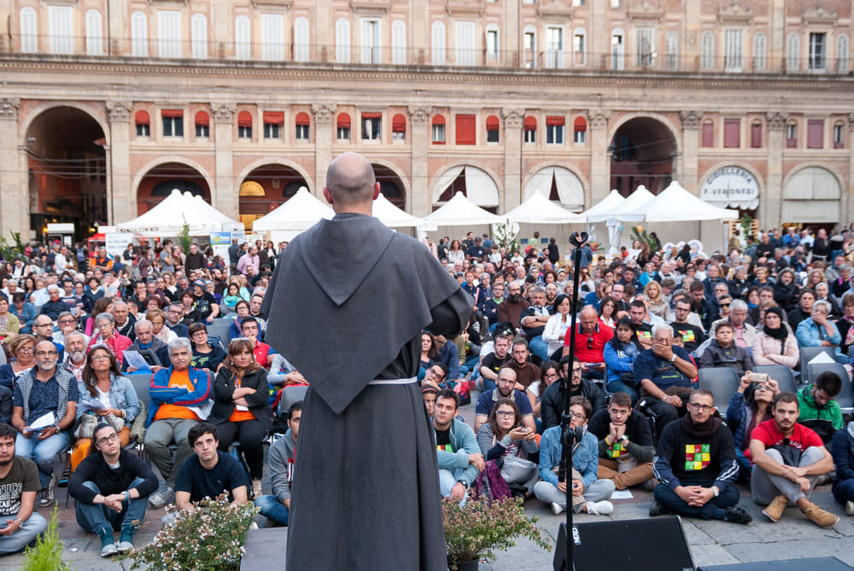  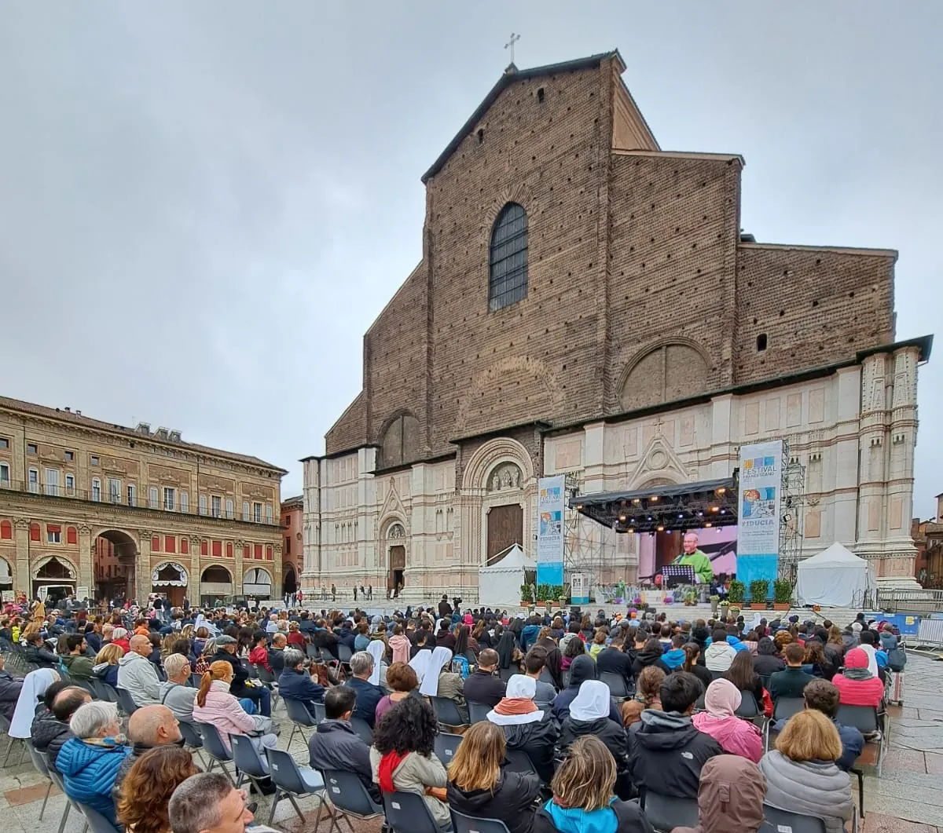  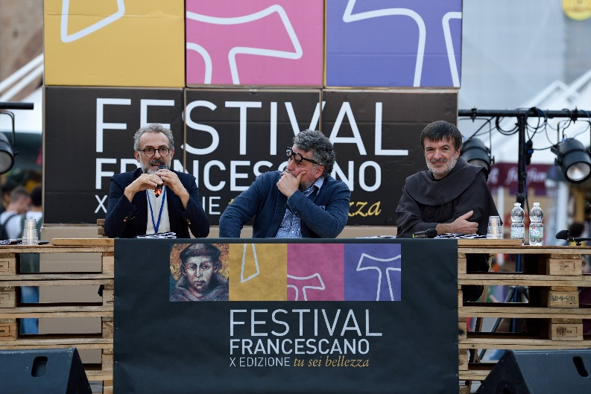
Title of practice: | Franciscan Festival

- Good practice detailed information
Short summary of the practice: | A regional event to disseminate the rules of St. Francis of Assisi. Prevention aspects of waste and sustainability.
Detailed information on the practice: | The Franciscan Festival was born in 2009 to celebrate the 800th anniversary of the approval of the first rule of St Francis of Assisi and aims to rediscover, make known, update and concretise the values of Francis of Assisi. It is organised by the Franciscan Movement of Emilia-Romagna, with the patronage and collaboration of the Region of Emilia-Romagna, the Metropolitan City of Bologna, and the Municipality of Bologna as part of the Bologna Summer programme.  It was decided to rely on the 'festival formula', creating an event that allows people to go out into the squares among the people.  Not only the physical squares of the cities (first Reggio Emilia, then Rimini and Bologna), but also the digital ones, of the web, where the Franciscan Festival continues to be an opportunity for meeting, dialogue, in-depth analysis and sharing.  In line with its mission, the event is attentive to sustainability and circularity both in content and in organisational/practical aspects. The programme includes free conferences, workshops and shows to raise awareness of environmental issues; the educational offer for schools and teacher training is particularly attentive.  The focus on waste separation is very high. The plastic, paper and undifferentiated waste collection bins are placed outside each stand grouping, near the main stage in Piazza Maggiore and then inside the "courtyard of honour". So, in all the strategic places where the various activities take place, so that the bins are available to the users of the Franciscan Festival. Near the coffee stand, the organic waste bins are also added, since it is mainly in that area that this type of waste is produced.  There is a volunteer appointed by the festival organisers who checks during the day that the bins are never too full and changes the bags regularly: this, as far as possible, avoids mixing different waste. Over the years there are many actions to try and enforce good practice and there is an awareness that we can always do better. When, for example, a waste has been thrown in the wrong bin, one tries to retrieve it and put it in the correct one: it is a small gesture that is worth a lot.
Resources needed: | The implementation was conceived and developed by the existing staff through the analysis of what was most suitable for our event, no new resources had to be added. The Festival aims to update the message of Francis of Assisi, who has always shown care for all creation, feeling called to take care of everything that exists.  On the financial side, there was an initial investment in the purchase of OSB panels and the connectors used to make up the various furnishings. This material is reused every year without any waste.
Timescale (start/end date): | The Franciscan Festival was born in 2009 and the developed to be an appropriate framework for a confrontation between even very distant positions. Each year a different theme is explored, one that is able to relate to contemporary issues.  A milestone was the 2019 edition, with 87% of waste sorted. About 3.000 plastic bottles were saved, about 500 aluminium flasks distributed and 6.000 meals were served in compostable crockery and containers.
Evidence of success (results achieved): | The set-up is made of ecological materials that are reused year after year:  - Environmentally friendly reusable furniture made of OSB wood panels (material purchased during the first editions)  - Consistently high separate waste collection rate (between 80% and 90%), agreement with the Municipality of Bologna and Hera Spa  - Totally plastic-free event (from 2019)  - An agreement is in place with the Municipality and Hera (waste company) for the minimization and differentiation of waste, with the provision of bins for each stand, and the installation of a free drinking water dispenser.  - They involve volunteers to supervise separate waste collection (Several associations in the Bologna municipality area were involved in the search for people)  - For attention to the environment, the promotion is Online and they prints the agenda on FSC-certified paper, for the main square only  - Absence of refreshment point in the square (except for coffee), to activate agreements with existing commercial businesses, thus reducing the use of disposable tableware  - Location is easily accessible via public transport (bike sharing, car sharing, taxi and buses)
Challenges encountered (optional): | The challenge of the project is to replicate an event in the city centre every year, always with an innovative and sustainable approach that can reach a large number of people.
Potential for learning or transfer: | This initiative has a high potential for transferability. Municipalities can play an important role in facilitating the transition to a new economic model that prioritises innovative practices upstream. The strengths of this practice are the network and documentation that the municipality has created with other organisations.
Further information: | The Franciscan Festival is a highly recognised event at national level, due to its importance for the topics it deals with and its ability to attract people from different backgrounds, and the 2023 edition had over 50,000 attendees (highest figure since post-Covid). The location of the festival is Bologna, mainly “Piazza Maggiore“, the heart of the city.
Keywords related to your practice | Transition, Integral Ecology, Dialogue, Sharing, Topical issues, Youth

*Please attach 3 pictures that describe your practice. Do not insert them into this document but send them as separate files, please.

- Additional info (only for MINEV project purposes)

This is simply to have some additional information and material for compiling the collection of good practices.
Testimonial: | Each year the event welcomes many people from all over Italy. Dream, Rules, Life was the central theme around which the 15th edition of the Franciscan Festival (September 21 to 24, 2023 in Piazza Maggiore in Bologna) revolved.  A strongly identifying theme for an event that aims to make known and spread in society, updating them, the Franciscan values of fraternity, justice, peace, respect for creation, intercultural and interreligious dialogue, and essentiality.
Person who gave the testimony: | Stefania D’Aiello

