Good Practice template
To submit a good practice, you must register on the Interreg Europe website. You can submit your good practice through your user dashboard (good practices).
- Author contact information
Contact information is filled out automatically and comes from your profile. You can edit it in your dashboard.
Preferably, the owner of the good practice should fill in the form. If you are not the owner, please indicate this below.
Are you submitting the good practice one someone else’s behalf? | No
Your details | Sofia
 | KARVELI
 | s.karveli@pde.gov.gr
 | +30 26 13 613 551

Are you involved in an Interreg Europe project?  If you are involved in more than one project, please choose the project for which you are submitting this good practice.  See our list of approved projects. | YES
In case ‘yes’ is selected, the following section appears:
Please select the project acronym: | CHERRY CHERRY - making Culture tHe N°1 ally of European RecoveRY | Interreg Europe - Sharing solutions for better policy

- Organisation in charge of the good practice
If your organisation is not the one in charge of the good practice, you can indicate the relevant organisation in this section of the form. Your contact details will still be linked to the submitted good practice.
Is your organisation the main institution in charge of this good practice? | Yes, along with the Hellenic Ministry of Culture

In case ‘yes’ is selected, you can review your organisation’s details. In case ‘no’ is selected, you can select an existing organisation or add a new organisation.
- Good practice general information
If you are submitting a good practice as part of an Interreg Europe project, the thematic objective and sub-topic are chosen for you.
If you are not part of an Interreg Europe project, please remember to choose the most relevant thematic objective and sub-topic for your good practice.
Thematic objective of the practice: | Urban Transformation  In case the good practice is not part of an Interreg Europe project, selection of one of the 24 specific objectives
Geographical scope of the practice: | Local
Location of the practice | Country | Greece
 | Region | Region of Western Greece
 | City | Messolonghi

Practice image | 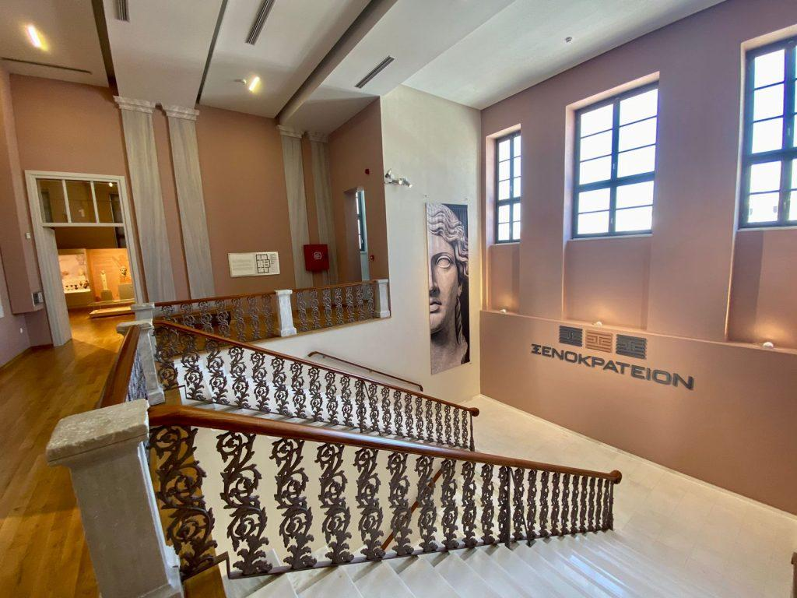  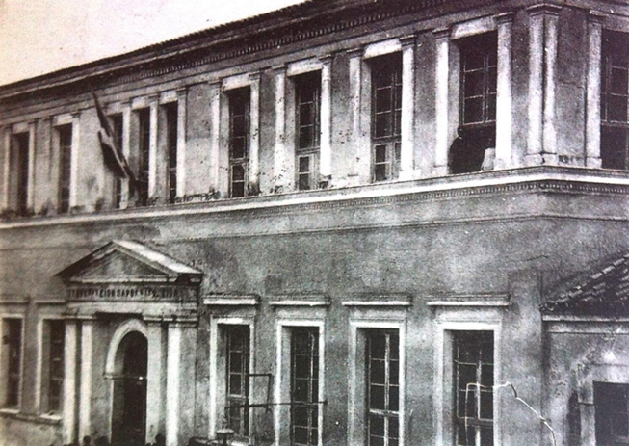  Upload your own (in compliance with the copyright rules) or select one from the pool of pre-defined images. Recommended dimensions: 440 x 450 pixels, 1MB.
Title of the practice | “XENOKRATEION” old school building restoration and transformation in a modern archaeological museum [100 characters]

- Good practice detailed information
The questions below in italic are optional.
Short summary of the practice: | 19th c. School declared “newer monument” due to its architecture & restored through the “Integrated Spatial Investment” tool setup by RWG for the wider area. [160 characters]
Detailed information on the practice: | Please provide information on the practice itself. In particular:  - What is the problem addressed and the context which triggered the introduction of the practice? XENOKRATEION was an historic yet abandoned building in the city centre of Messolonghi causing subsequent urban degradation. A twofold “Integrated Spatial Investment'' (ISI) made of 2 pillars, culture & environment, was elaborated with XENOKRATEION building restoration at the forefront of the cultural pillar, to upgrade both, the central city building-environment along with overall urban development through wider cultural services, justified also by the impressive increase of archaeological finds that came to light during recent infrastructure works.  - How does the practice reach its objectives and how it is implemented? The “ISI” is an explicit institutional tool allowing for a comprehensive development approach to be further implemented by a strategic plan; it constitutes an eco-development and spatial planning model based on the carrying capacity of the natural and cultural capital of a specific area, here the Messolonghi lagoon, the largest lagoon in Greece. The twofold “ISI of Messolonghi – Aitolikos” consists of 2 priority axes (environment & culture) and comprises 40 projects, one of which is the XENOKRATEION building restauration and transformation in a modern archaeological museum operated by the Ministry of Culture local services. Within this context, of an “ISI'' adjusted to the area needs, XENOKRATEION represents the local practice for urban transformation.  - Who are the main stakeholders and beneficiaries of the practice? The main stakeholders are local, regional, and national competent authorities involved in the implementation of XENOKRATEION museum.  [1500 characters]
Timescale (start/end date): | ongoing, as from March 2019
Resources needed: | Please specify the number of funding/financial resources used and/or the human resources required to set up and to run the practice.  [300 characters]  The XENOKRATEION building restoration cost of 2.257.950,96 € was financed by the Regional Operational Program "Western Greece 2014-2020. It was inaugurated 12/2021 and practically open since 2022: too short to calculate impact on local tourism"
Evidence of success (results achieved): | Why is this practice considered as good? Please provide factual evidence that demonstrates its success or failure (e.g., measurable outputs/results). [500 characters]  - restoration of an historic building.  - establishment of a missing archaeological museum in an area accounting for landmark historical events, as the Actium naval battle 31 BC.  - regeneration of the city centre with the museum ensuring a new entertainment & education pole, promoting socio-cultural life with positive spillover effects on the local economy.  Considering the small city size and Covid-19 restrictions, the 2 years’ operation accounting for > 7.570 visitors/year is a local success.
Potential for learning or transfer: | Please explain why you consider this practice (or some aspects of this practice) as being potentially interesting for other regions to learn from. This can be done e.g., through information on key success factors for a transfer or on, factors that can hamper a transfer. Information on transfer(s) that already took place can also be provided (if possible, specify the country, the region – NUTS 2 – and organisation to which the practice was transferred)  - Relevance: XENOKRATEION directly links with sustainable urban regeneration & upgrade of cultural public services.  - Impact: from opening (12/2021) an average of 7.570 visitors/year (5.507 adults+9.634 pupils): a significant figure considering the Messolonghi city size (<32.000 inhabitants).  - Replicability lies with the well-known concept of old buildings’ restoration & transformation into modern museums to boost urban regeneration through cultural offer (ex. Le Louvre Lens, Guggenheim Museum Bilbao)  - Sustainability: secured by the Messolonghi “ISI”.  - Innovation: threefold: 1) the concept: historical building restoration used to leverage urban regeneration 2) establishment of a missing museum to promote archeological heritage and upgrade cultural offer regionwide 3) funds’ combination: the integrated strategy (study) and the building restoration was financed by Western Greece ROP 2014-2020 while the XENOKRATEION museum is operated by Ministry of Culture.  [Technical: A good practice be edited throughout a project lifetime (e.g., to add information on the transfers that have occurred)]  [1000 characters]
External website (optional): | XENOKRATEION museum website Link to where further information on the good practice can be found
Tags related to your practice (optional): | Select from existing keywords  Select existing keywords or add ( excel files Tags)Tags
Documents (optional): | Add documents to support your good practice
Video (optional): | Add a video to support your good practice
Images (optional): | Add images to support your good practice  